**Normalization**

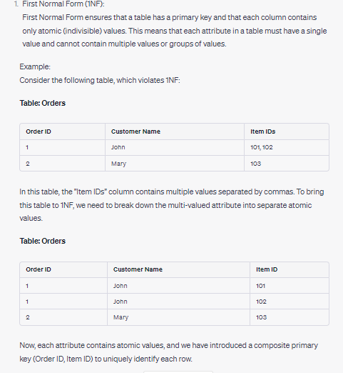

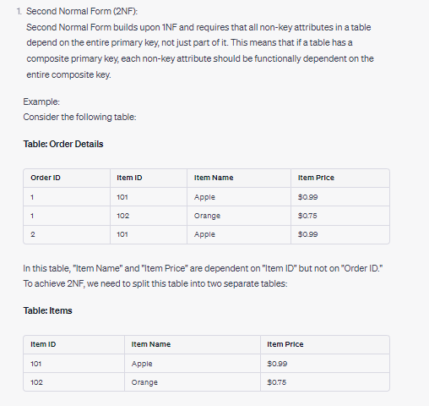

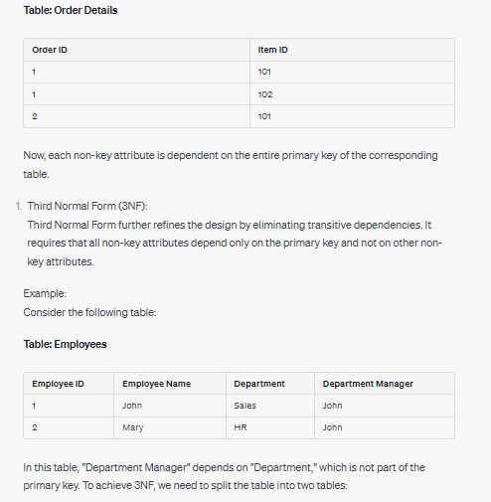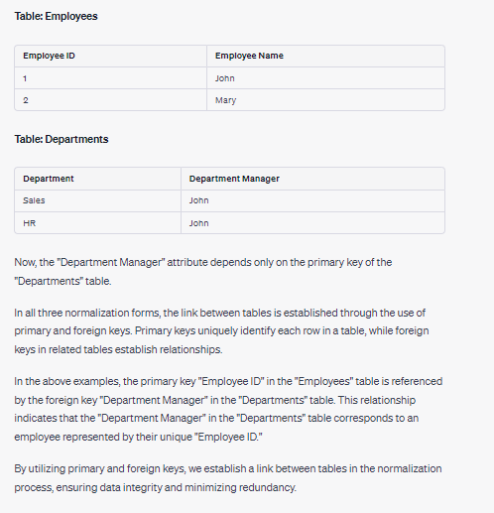

<https://www.guru99.com/database-normalization.html>

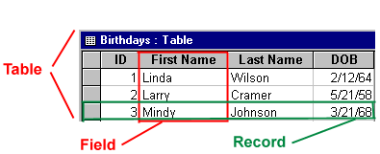

A record: Contains specific data, like information about a particular employee or a product. A field: Contains data about one aspect of the table subject, such as first name or e-mail address.

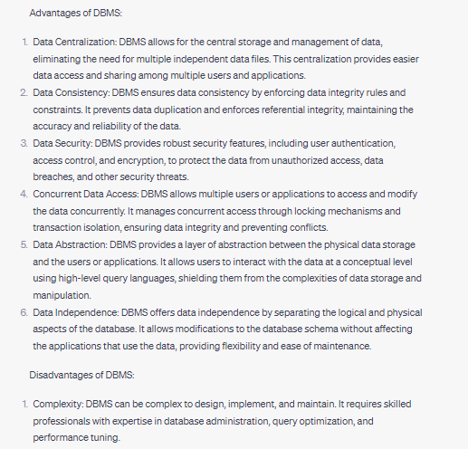

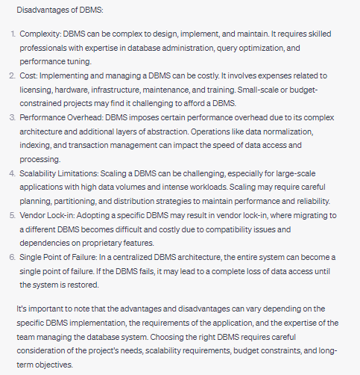

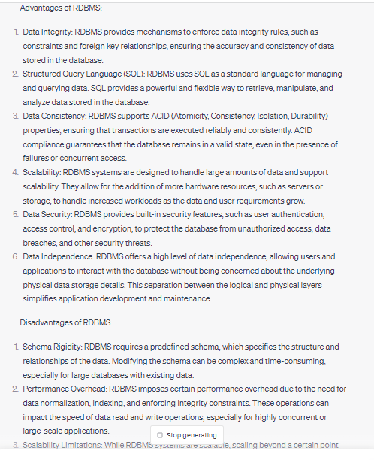

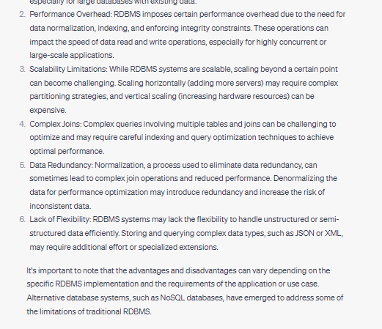

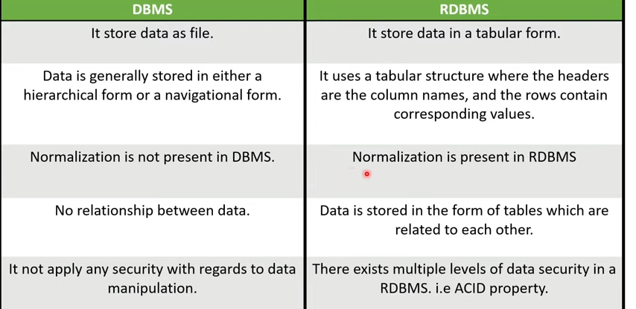

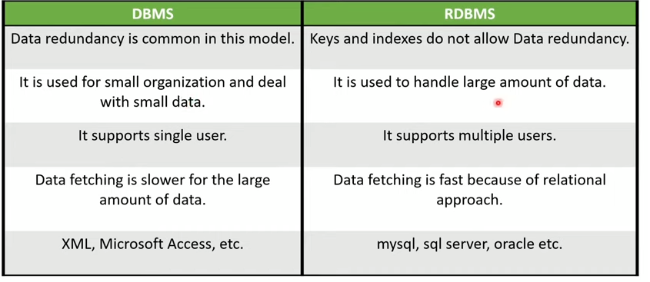

<https://www.youtube.com/shorts/H6sJDrEOKDc>

# **Transactions**

# 

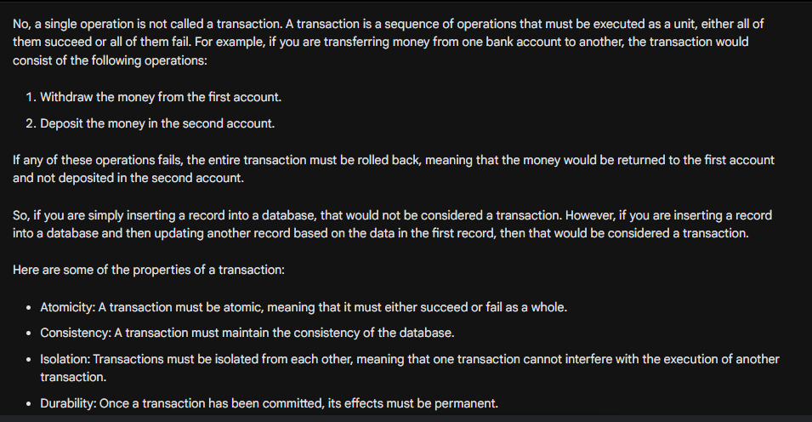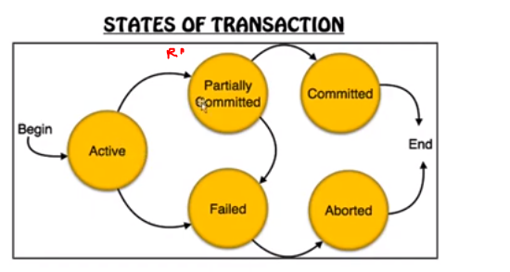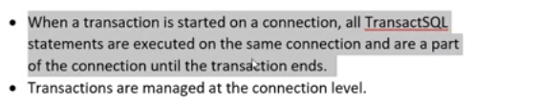

Connection level yani humny jo window tab open kia hota wo ek connection,gr ek aur tab open kr lain tu wo dusra connection.

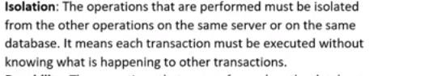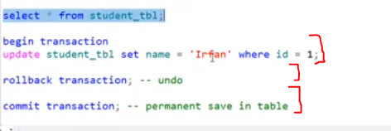

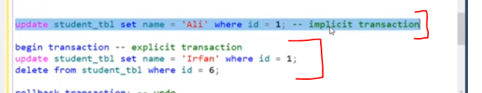

Figure 1Agr hum begin transaction sa khud start krain yani tu wo explicit otherwise without begin transaction ka wo implicit transaction hi hoti ha hamari normal koi query aur usko hum rllback nhi kr skty

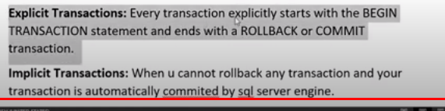

# **Views**

Hum nahi chahty ka hamara use sary columns dekhy kisi table ka tu hum us table ka view bana kr usko sirf kuch columns tables ka dikhaty sary nahi. Views can be used as a mechanism to implement row and column level security.Column level security mtlb hum un columns ko output ma na print krwaien and row level security means ka hum koi condition like where laga dain ka ye wali rows na print hon

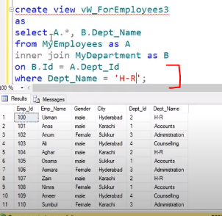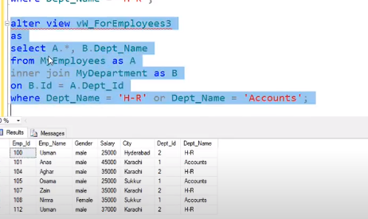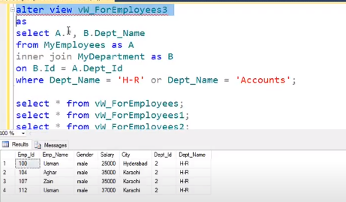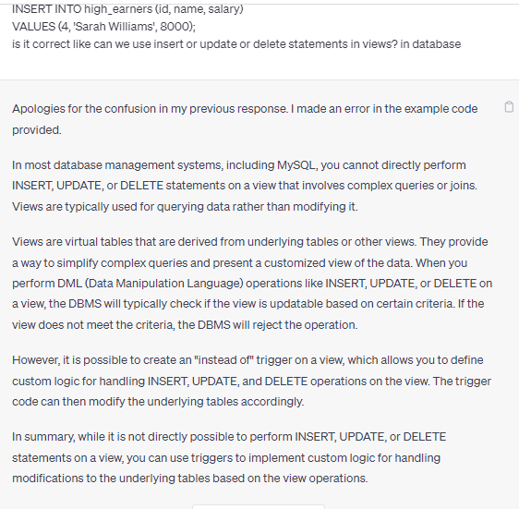

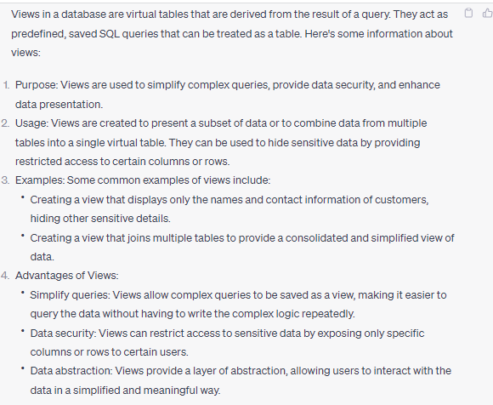

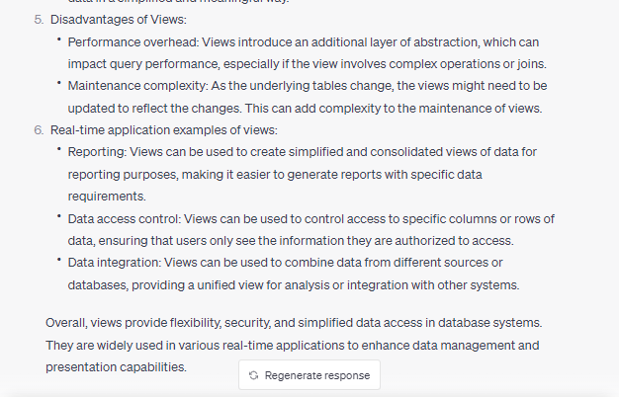

**Foreign keys?**

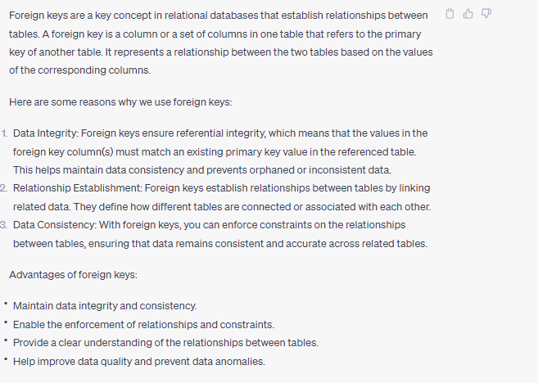

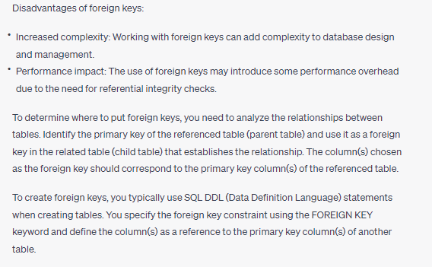

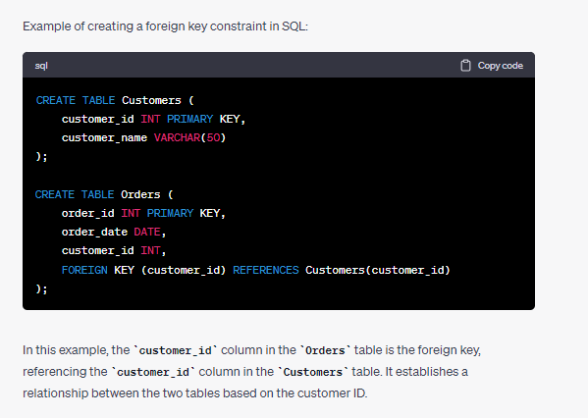

**Anomalies and types of anomalie** 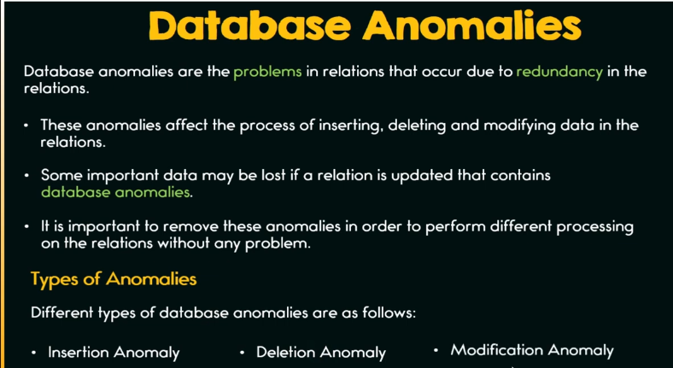

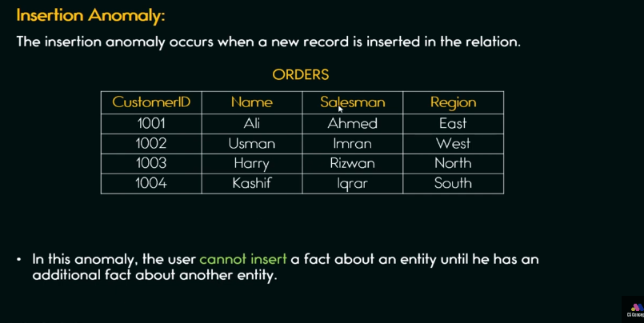

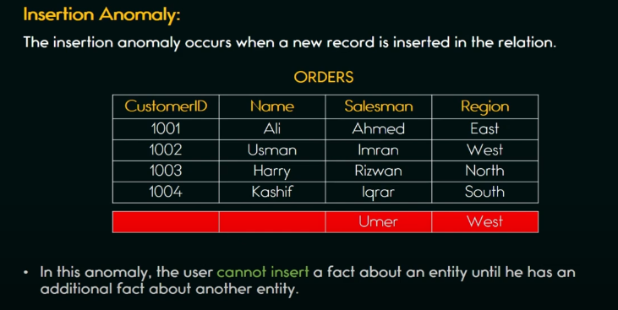

Hum ek new record tb tk insert nahi kr skty jab tak hamary pas uski additional information na ho jaisy hum new salesman ha usky record nhi enter kr skty kionky hamain primary key customerID ha aur hamain id aur name bhi enter krna ho ga.Inshort hamain sirf salesman aur region entry krni ha table ma but hum wo nahi kr skty kionky customeid aur name bhi dalna pry ga tu humain addition information dalni pry gi if we want to insert record.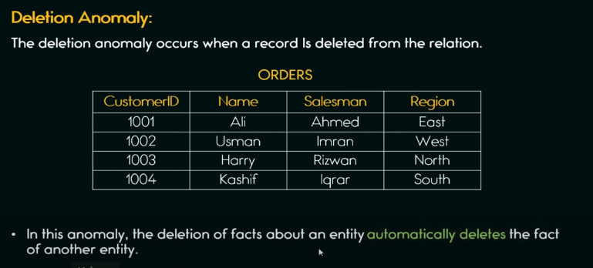

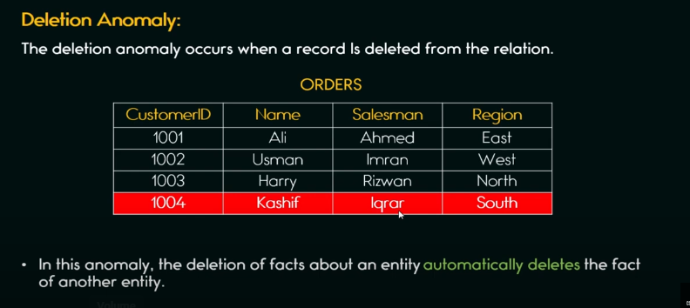Msln hum Kashif customer ka data delete krna chahty hain pr salesman aur region ka yani puri record(row) automatically delete ho jay gi.

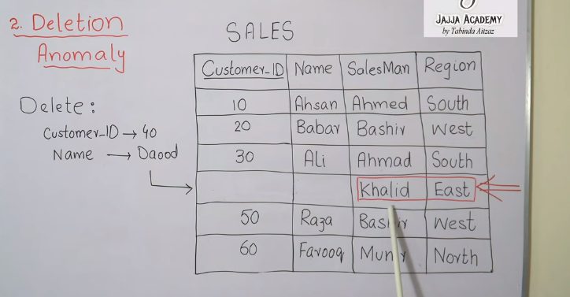

Msln hum sirf ek row ki 2fields ko delete krna chahty thy but kionky customerID primary set ha tu humain majbori ma puri row/record delete krna ho ga

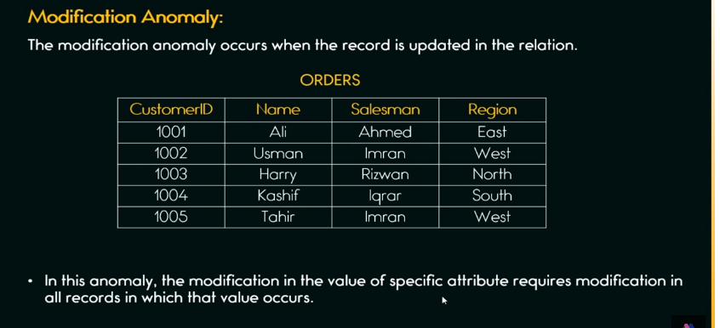 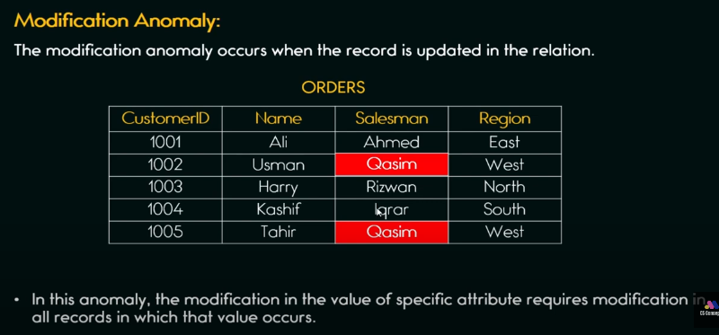

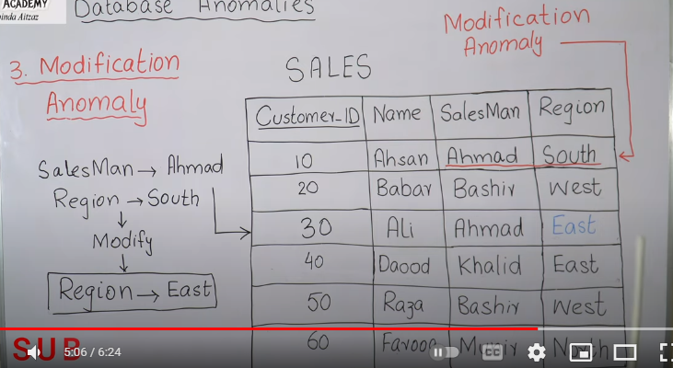

Ab ma chahta ka jahan jahan salesman Ahmad ha uska region update ho jay pr ab jahan ma nahi chahta wahan bhi update ho raha yani ma tu chahta tha sirf Ali ka salesman Ahmad ka region update ho pr wo tu Ahsan ka bhi kr raha.

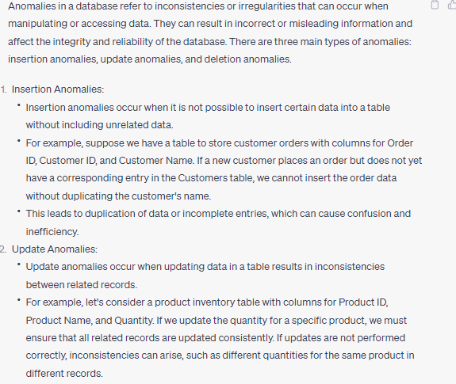

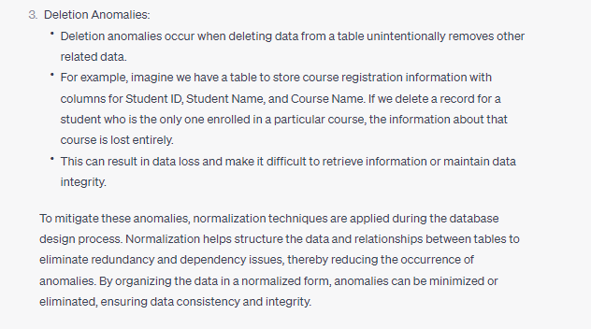

Data anomalies ki waja sa data redundanduncy hoti ha

**What is Indexing**

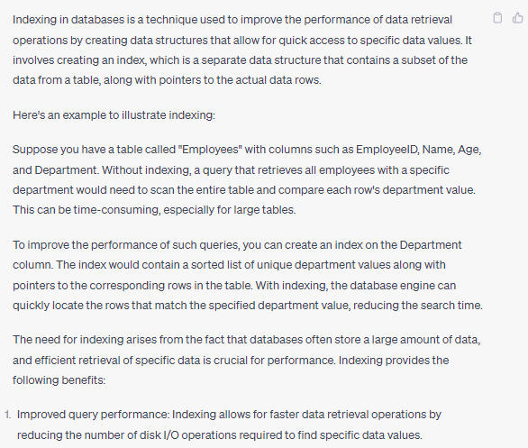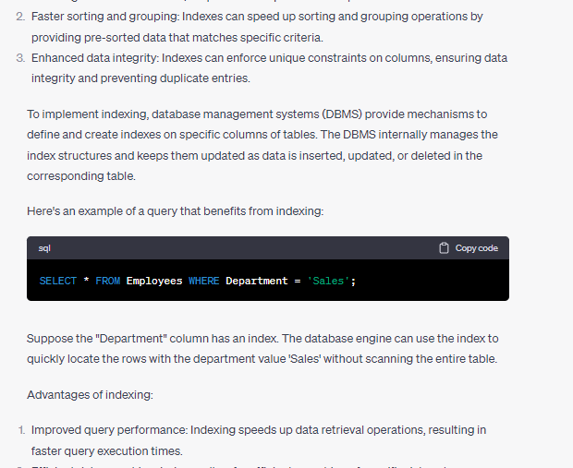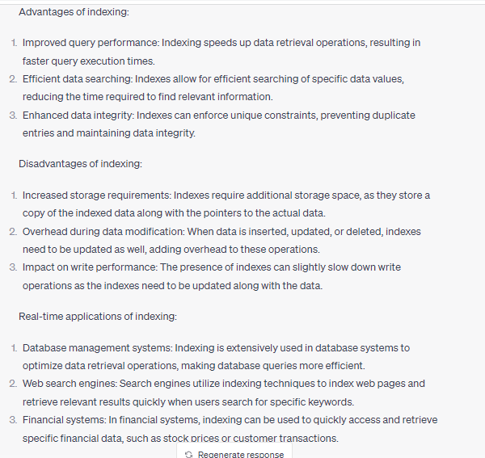

**Difference between procedure and function**

A function is used to calculate result using given inputs. A procedure is used to perform certain task in order. 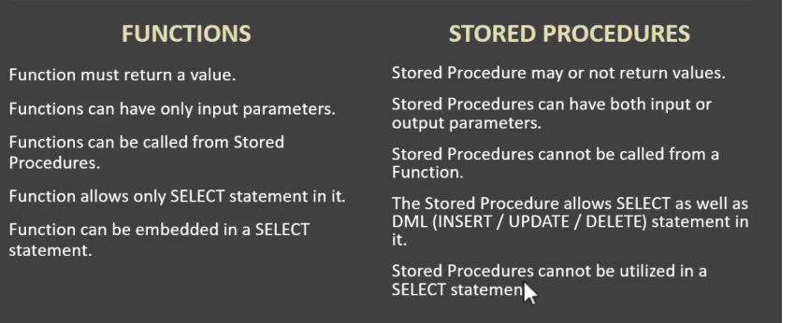

Functions kohum jaisy select sum(columnName) from table yani select ma embed kr skty pr stored procedures ko nahi kr skty. 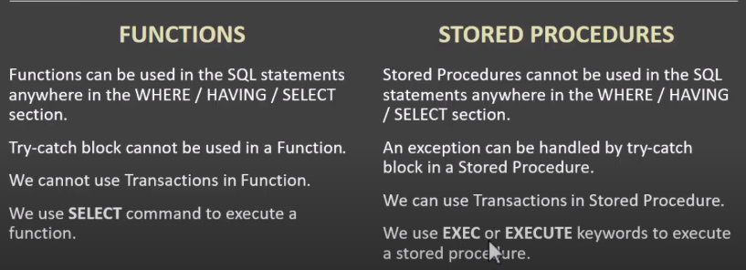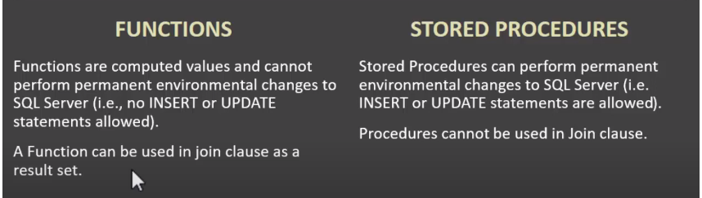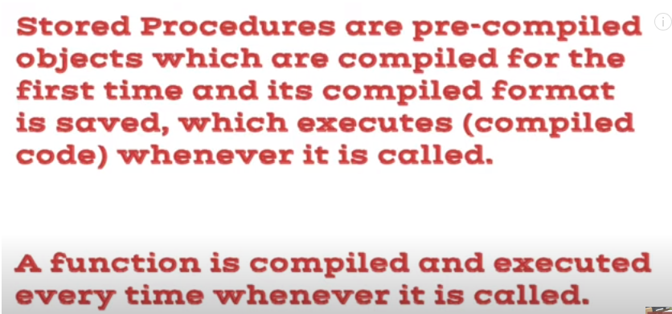

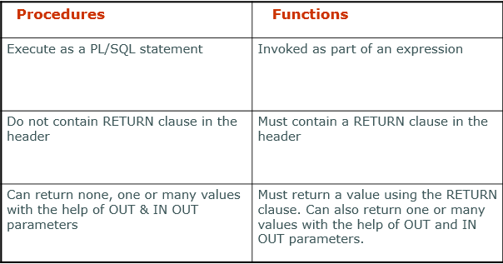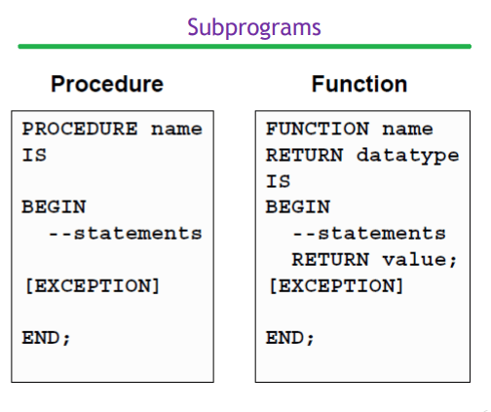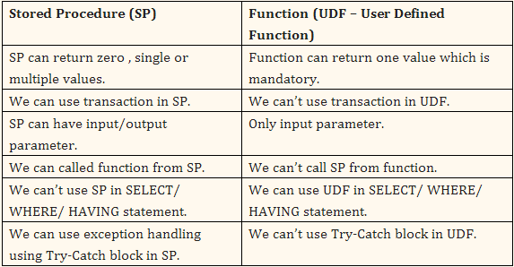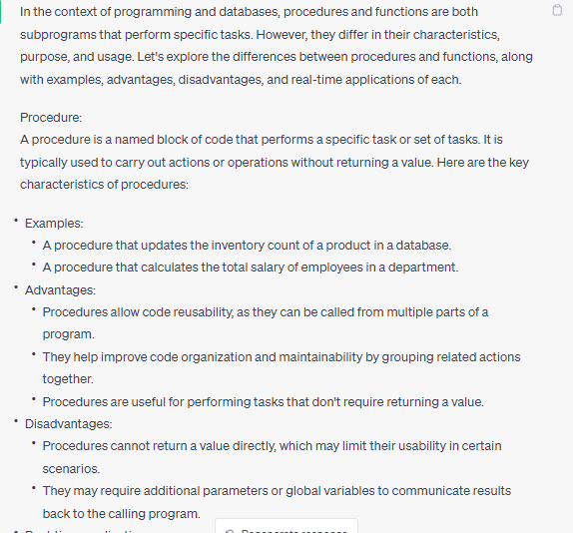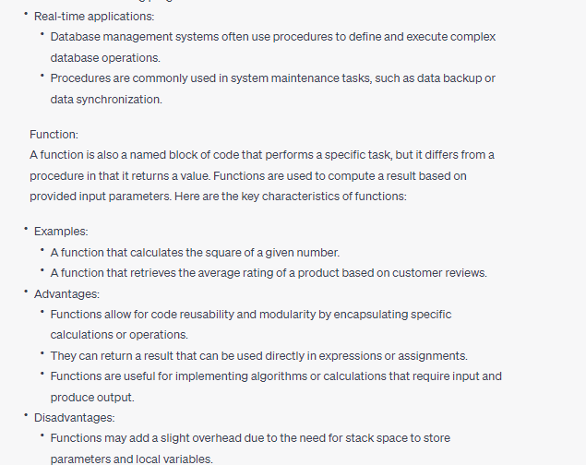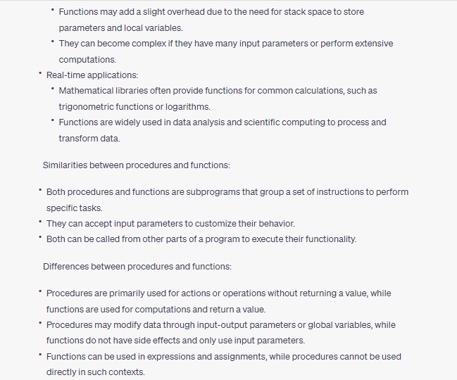

In summary, procedures and functions serve different purposes in programming. Procedures are used for performing actions or operations, while functions are used for computations and returning results. Both have their advantages and disadvantages, and their usage depends on the specific requirements of the program or system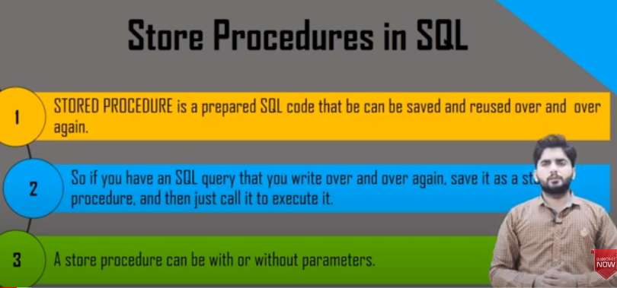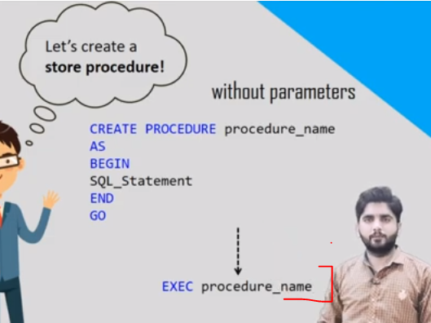

Is procedure ko call(execute) krny ka liay hum exec command use krty hain.Procedure can be with or without parameters.

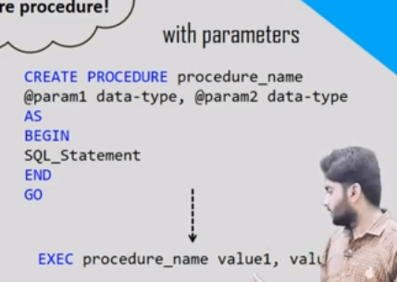

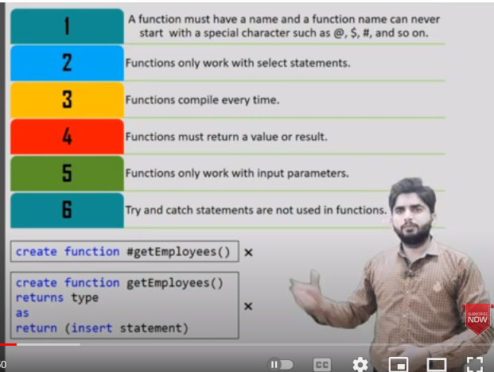

* Functions ma hum sirf select statements likhty hain Jbky procedures ma hum select/delete/update statements likh skty hain.
* Functions must return a value.
* Functions hr time jab call hon ga tu wo compile hon ga jbky stored procedure bs ek dafa compile hota.
* Functions ma hum try-catch block use nahi kr skty pr procedures ma hum try-catch block use kr skty hain**.**
* 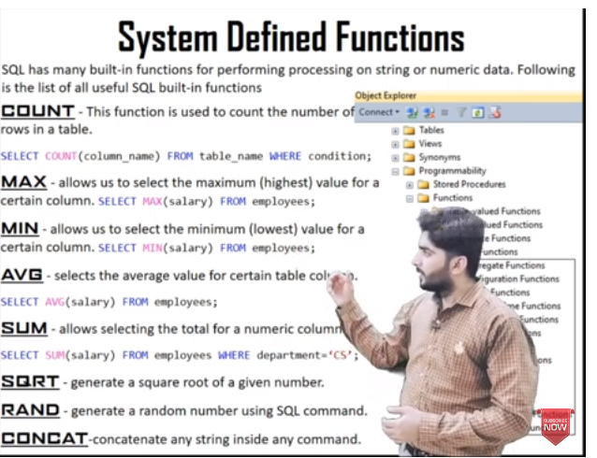
* 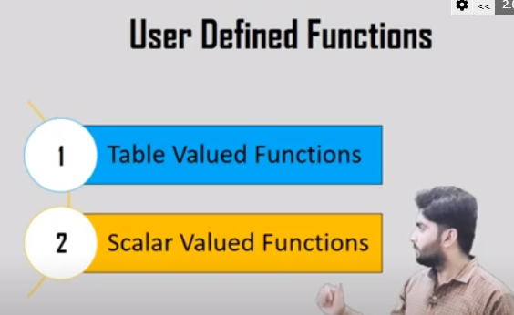

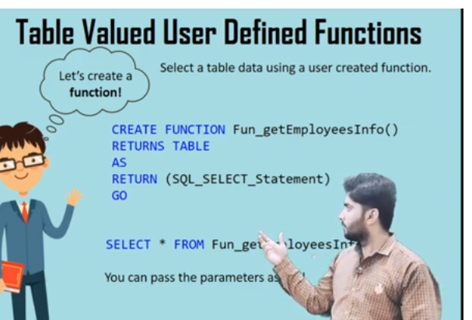

Table valued functions tables return krwaty hain jbky scalar valued functions koi value return krty hain.

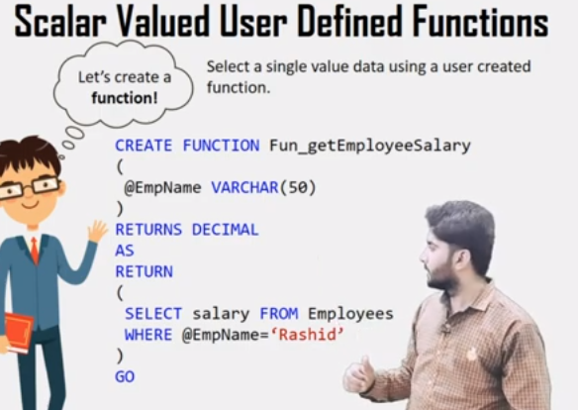

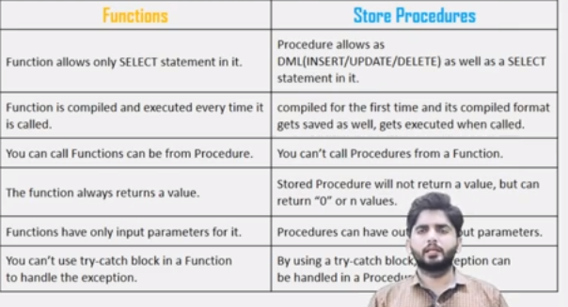

<https://www.youtube.com/watch?v=BOiwFJRgHeY>

https://www.youtube.com/watch?v=VX4OvU1pp1Y

jb hamain stored procedures sa koi values return krwani hon tu hum output parameters use krty hain.Functions ma hum sirf input parameters la skty hain yani functions ma output parameters lena allow nahi.

Procedure ko 3 mthod sa call kr skty hain:

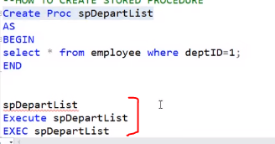

How value return from procedure

**Jb hum procedures ka andr sa koi value bahir bhejna access krna chahty tu hum output ka variable use krty hain.Function call krty wqt is variable kaandr hum kuch nahi bhejty na bhej skty kionky ye output variable ha ismy output store ho gi return ho gi.**

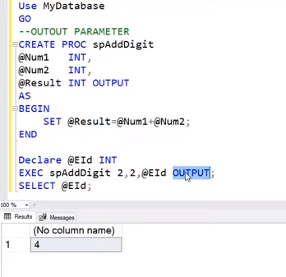

What are named variable?

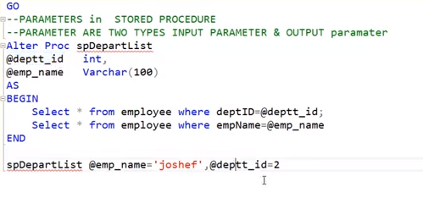

Hum jis sequence ma bhejty argumnts waisy hi assign hoty pr agr hum chahty ka jo value bheji wo isko assign ho chahy koi bhi order ho tu hum aisy bhejty isko named variable kehy hain.

**Truncate vs delete vs Drop**

The DELETE command deletes one or more existing records from the table in the database. The DROP Command drops the complete table from the database. The TRUNCATE Command deletes all the rows from the existing table, leaving the row with the column names.

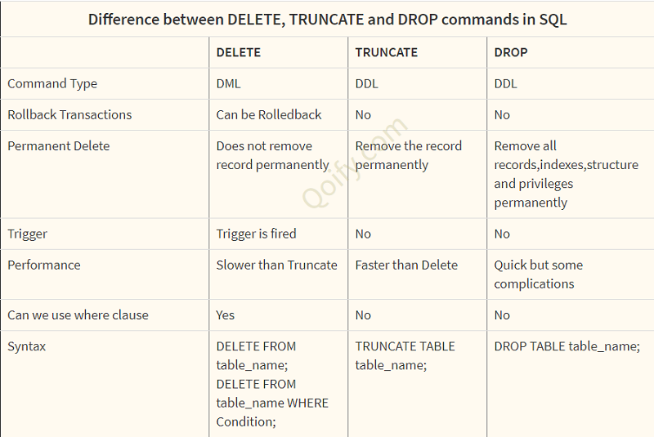

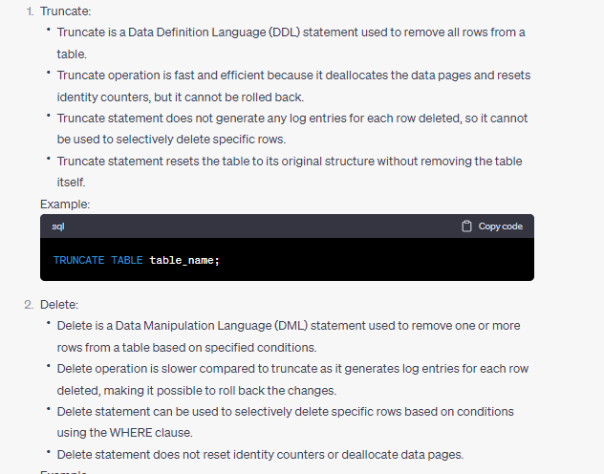

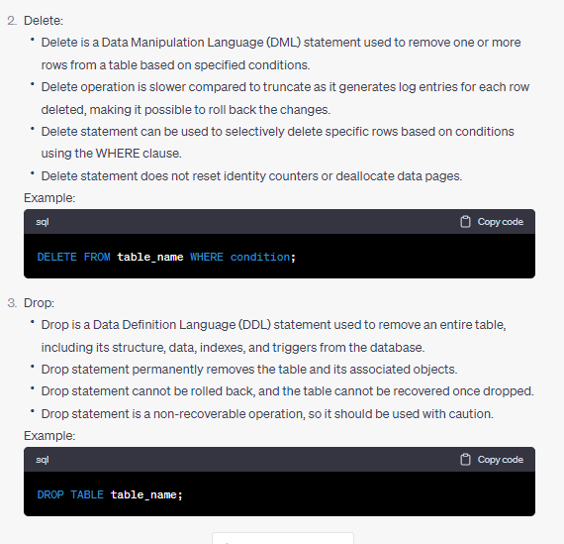

In summary, Truncate is used to remove all rows from a table quickly, Delete is used to selectively remove specific rows from a table, and Drop is used to permanently remove an entire table from the database. The choice between these statements depends on the specific requirements and impact on the data and table structure.

**Unique key vs primary key**

Primary Key is used to uniquely identify a row but a unique key is used to prevent duplicate values in a column.

Existence : A table can have only one primary key but it can have multiple unique keys.

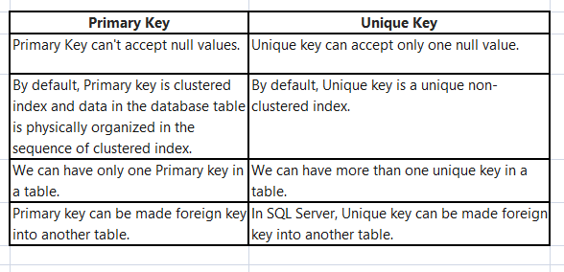

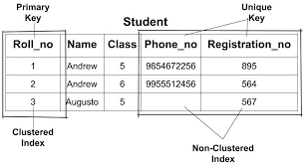

**We make tables to store data in a particular structure.** **Schema diagram representation is ER Diagram**

**Database system vs file system**

File system ek banda access kr skta jabky dbms kahien sa bhi koi access kr skta cloud based.file system jaisy hamary os windows ma inbuilt hota ha.Class ma register pr attendance lety file system.We are now following client-server architecture that is dbms.

**Memory utilization is less and searching is fast in dbms:**Msln word ma ek table banaya usmy attribute ha salary ka ab hum dekhna chahty ka wo tamam employes jinki salary 2500 sa ziada tu hamain har row ma ja kr us particular cell ma manually dekhna ho ga but yehi dbms ma hum ek select query ka sath kr skty easily.isi trha aggregate functions etc are helpful in dbms.

**Security**(Role based control access hoti ha dbms ma).File word ma hum lock kr skty hain msln password laga dia agr sahi pswd tu word file open ho gi but file ma table ha jismy diff column hum restrict nhi kr skty user ko ka wo sirf 2 column access kr sky baki 2 nahi but dbms ma database administrator hota aur usmy hum restictions laga skty ka konsa user kitna kia data access kr skty.

**Data redundancy** nahi hoti dbms ma jbky Data integrity hoti ha dbms ma.i.e lots of constraints jaisy primary key ka concept ha aur data integrity ensure krna etc.

1. **Data Management Features:** Database systems offer advanced features like indexing, query optimization, data backup and recovery, security controls, and data sharing across multiple applications. File systems primarily focus on file storage and retrieval, without providing these additional capabilities.

**What is Data integrity?**

Data integrity refers to the accuracy, consistency, and reliability of data over its entire lifecycle. It ensures that data remains complete, valid, and trustworthy throughout various operations, such as storage, processing, and transmission. Data integrity is crucial to maintain the quality and reliability of data in databases and information systems.

Here's an example to illustrate data integrity:

Let's consider a database table that stores customer information, including their name, email address, and phone number. The table has a constraint that ensures each customer's email address is unique.

Suppose a new record is being inserted into the table with the email address "example@example.com." The data integrity constraint will validate whether this email address already exists in the table. If a record with the same email address already exists, the constraint will prevent the insertion, maintaining the uniqueness of email addresses.

This ensures data integrity by preventing duplicate or inconsistent data from being introduced into the system. It helps maintain the accuracy and reliability of the customer information, ensuring that each email address is unique and valid.

Data integrity can also be enforced through other means, such as referential integrity constraints, which ensure that relationships between different tables are maintained correctly. For example, if there is a relationship between a "Customers" table and an "Orders" table, referential integrity ensures that a customer cannot be deleted if they have associated orders in the "Orders" table.

Overall, data integrity mechanisms and constraints play a crucial role in upholding the quality and reliability of data, preventing inconsistencies, and ensuring accurate and trustworthy information within databases and information systems.

**What is DBA**

**What is Schema**

A database schema is a **blueprint** or **architecture** of how our data will look. It doesn’t hold data itself, but instead describes the shape of the data and how it might relate to other tables or models. A sample of data at any given point in time represents a **database instance.** It will contain all of the properties described in the schema. It provides a logical representation of the database and specifies the layout of tables, columns, data types, and relationships between them.

**What is ERD Diagram**

An ERD (Entity-Relationship Diagram) is a visual representation of the relationships between entities in a database. It is a modeling technique used to design and document a database system. An ERD diagram helps to visualize the structure of a database, showing the entities (objects or concepts), their attributes (properties or characteristics), and the relationships between them. 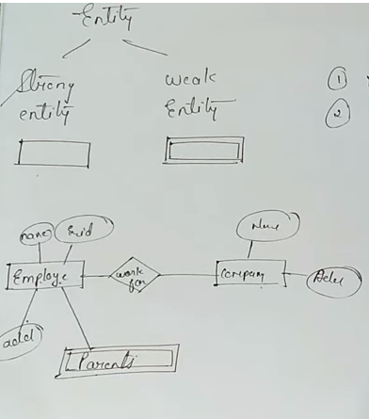

**What is Relations btw tables and why they need?**

Database design is basically called schema in technical terms that is the logical representation of database.

**Question Why when a record deleted from a table and for new entry of data happens in table then why we can’t use the id of previous deleted record for the new data record when the ID column is set to be the primary key?**

In a typical scenario, when the primary key column is set in a table, it ensures the uniqueness of each record's identifier. The primary key is usually an auto-incrementing value, meaning that it automatically assigns a new, unique ID to each record as it is inserted into the table.

Let's consider the situation you described: if the 5th record is deleted from the table and a new entry is added afterward, the new record will be assigned the next available ID, which would be the 6th ID in this case. This behavior is because the primary key column is designed to generate a unique identifier for each record, regardless of the existence or deletion of previous records.

In many database management systems, the auto-incrementing behavior is handled internally by the system itself. It keeps track of the last assigned ID and increments it when a new record is inserted. Therefore, the system does not reuse IDs that have been previously assigned or take into account the deleted records when generating the ID for a new entry.

This approach guarantees that each record in the table has a distinct identifier, maintaining the integrity of the primary key constraint and avoiding potential conflicts or confusion in the identification of records.

**Top of Form**

**agr humny column id primary set kia ha aur 5th record delete kia tu new record ka liay 6th id use ho gi 5th nahi .This is because of the primary key that is ensuring the uniqueness of the entry.**

**Question :What is difference between signed and unsigned integers and for primary key which one integer type is best?**

Signed and unsigned integers differ in how they represent and interpret numeric values. The main distinction lies in whether the integers can represent both positive and negative values (signed) or only non-negative values (unsigned).

Signed integers use a portion of their binary representation to indicate the sign of the number. The most significant bit (MSB) is reserved as the sign bit, where 0 represents a positive value and 1 represents a negative value. The remaining bits represent the magnitude of the number. This means that signed integers can represent both positive and negative values, allowing for a wider range of values to be stored.

On the other hand, unsigned integers do not have a sign bit. Instead, all the bits in the binary representation are used to represent the magnitude of the number. As a result, unsigned integers can only represent non-negative values, starting from zero and going up to the maximum value that can be represented by the specific integer type.

When it comes to choosing the integer type for a primary key, the decision depends on the requirements and characteristics of the data being stored.

If the primary key values are strictly non-negative and the range of values required fits within the maximum value of an unsigned integer, using an unsigned integer type can be beneficial. It allows for a larger range of possible values and avoids the need to reserve a bit for the sign, potentially optimizing storage and memory usage.

However, if the primary key values may include negative numbers or require a wider range of values that exceeds what can be represented by an unsigned integer, a signed integer type would be more appropriate.

In general, the choice between signed and unsigned integers for a primary key depends on the specific needs of the application and the range of values expected for the primary key column. It's important to consider the potential range of values, the storage requirements, and the potential implications for arithmetic operations or comparisons involving the primary key values.

**DDL vs DML**

DDL table pr lagti ha aur DML rows pr lagti ha

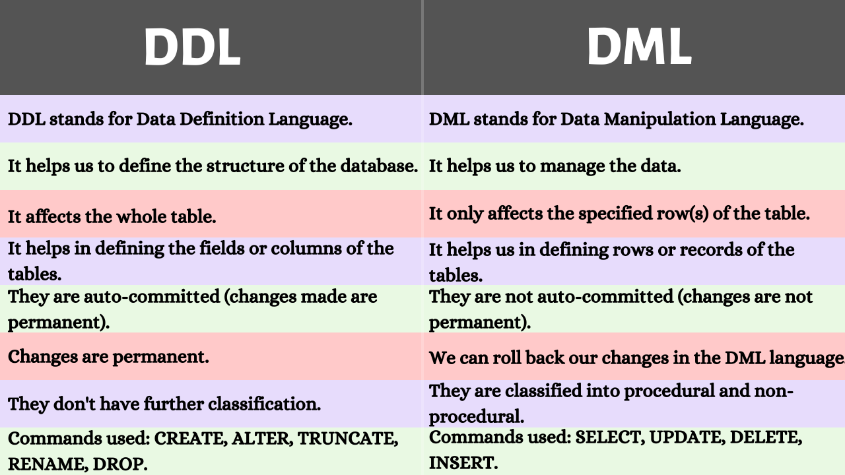

DDL (Data Definition Language): DDL statements are used to define and manage the structure of database objects. They are responsible for creating, altering, and dropping database objects such as tables, views, indexes, and constraints. DDL statements do not manipulate data directly but rather define the structure and rules for data storage and retrieval.

DML (Data Manipulation Language): DML statements are used to manipulate data within the database. They allow you to perform operations such as inserting, updating, deleting, and retrieving data from database tables.

**Question:What is Three tier architecture?**

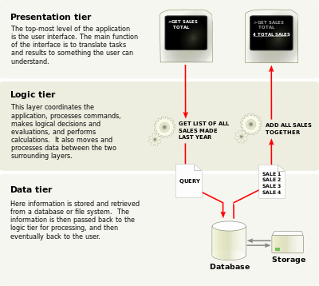

i.e humny ase ka liay apply krna tu pehly form fill krain ga then data wahan jay ga

ye 3tier but agr hum khud hi direct ms excel ma data enter krky save krain wo 2tier. The 3-tier architecture is a design pattern commonly used in software development, including database systems. It separates the application into three distinct layers, each with its own specific responsibilities. These layers are the presentation layer, business logic layer, and data storage layer. Here's a breakdown of each layer and an example of how it can be implemented:

1. Presentation Layer (User Interface):

The presentation layer is responsible for interacting with users and presenting information to them. It handles user input, displays data, and provides a user-friendly interface. This layer can consist of web pages, mobile applications, or any other means of user interaction. It focuses on the visual aspects of the application and does not directly interact with the database.

Example: In a web application, the presentation layer can be implemented using HTML, CSS, and JavaScript. It handles the rendering of web pages, captures user input through forms, and sends requests to the business logic layer for processing.

2. Business Logic Layer (Application Layer):

The business logic layer contains the core functionality and processing logic of the application. It performs tasks such as data validation, business rules enforcement, and application-specific operations. This layer receives requests from the presentation layer, processes them, and returns the results. It acts as an intermediary between the presentation layer and the data storage layer.

Example: In an e-commerce application, the business logic layer handles operations like adding items to a shopping cart, processing payments, calculating discounts, and managing inventory. It validates user input, performs necessary calculations, and interacts with the data storage layer to retrieve or update data.

3. Data Storage Layer (Database Layer):

The data storage layer is responsible for managing the persistence and retrieval of data. It typically involves a database management system (DBMS) and handles tasks like data storage, retrieval, querying, and management of the underlying database. The data storage layer interacts with the business logic layer to provide the required data.

Example: A relational database management system (RDBMS) like MySQL or PostgreSQL can be used for the data storage layer. It stores data in tables, enforces data integrity through constraints, and allows for efficient querying using SQL. The data storage layer provides the necessary CRUD (Create, Read, Update, Delete) operations to the business logic layer.

To implement the 3-tier architecture, you would design and develop each layer separately, ensuring clear separation of responsibilities. The layers can communicate with each other through well-defined interfaces or APIs. The presentation layer interacts with the business logic layer to send user requests and receive processed data. The business logic layer interacts with the data storage layer to retrieve or update data as needed.

By following the 3-tier architecture, you achieve modularity, separation of concerns, and scalability. It allows for easier maintenance, enhances reusability, and promotes a clean separation between user interface, business logic, and data management components in your application.

**Question : What * in Select query is representing?**

Ans: It represents that select all the columns

**Question: Types of delete?**

Ans : There are 2 types of delete like

i.e You passed the id and say delete it then it is safe delete because only passed id data will be deleted.

i.e You did’nt pass id and say delete it then it is unsafe delete because all data will be deleted.

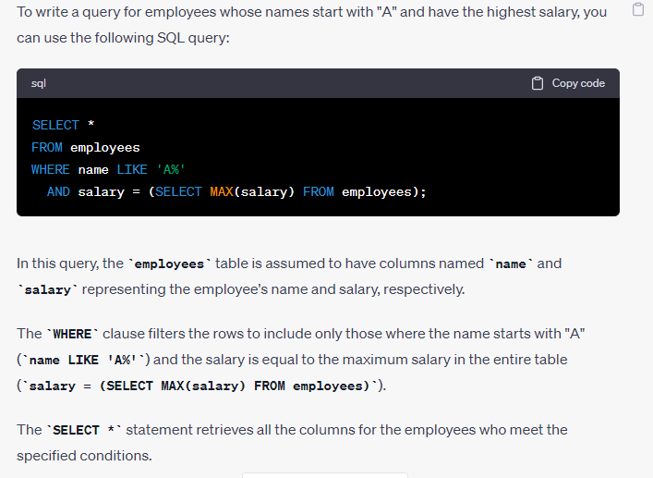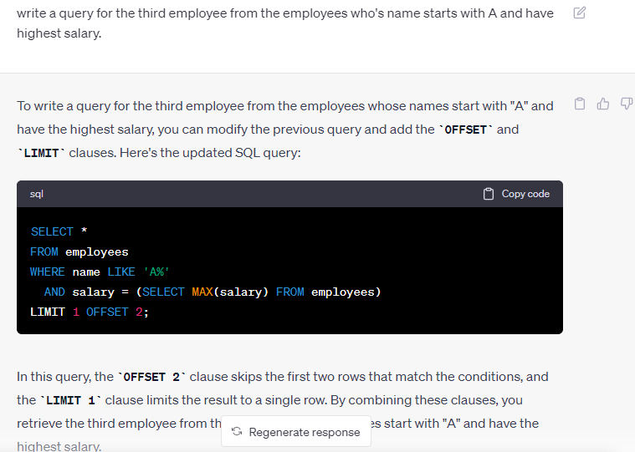**Delete duplicate rows from the table**

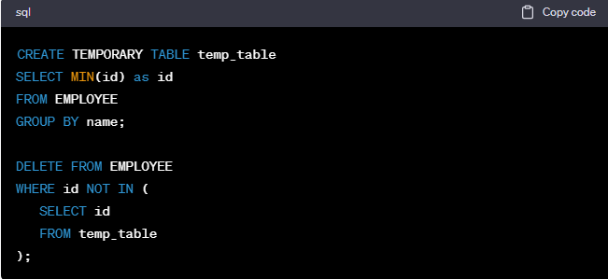

Condition: ye code sirf tb kam kry ga jb id primary key ho gi.

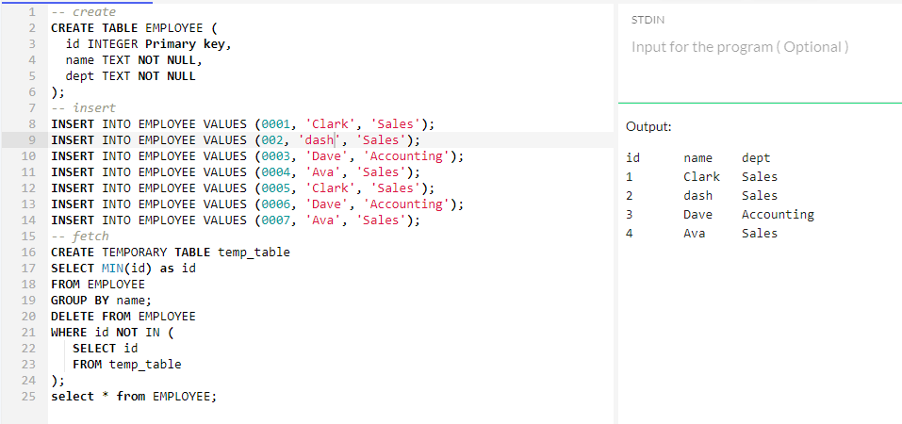

Explanation :

Yani ye pehly ek temporary table banata ha aur usmy data insert kr raha ha sirf unique sln jb duplicate rows ka group banata tu usmy min id wala record utha kr temp table ma rakh dety.then phir delete krty one by one wo tamam records jinki id us temporary table wali id sa match nhi krti.

Agr hum khali ye likhain

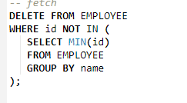

Tu error ayy ga ka **You can't specify target table 'table_name' for update in FROM clause**

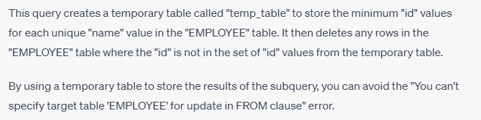



What is SQL injection?

SQL injection is a security vulnerability that occurs when an attacker inserts malicious SQL code into a database query. This can result in unauthorized access to sensitive data or the manipulation of data within the database.

1. What is a database? A database is a collection of data that is organized and stored in a way that makes it easy to access, manage, and update. Databases can be used to store a wide variety of data, from simple lists of names and addresses to complex, multi-dimensional datasets.
2. What are the different types of databases? What are the differences between them? There are several different types of databases, including:

* Relational databases: These databases store data in tables, with each table representing a different type of entity (e.g., customers, orders, products). The tables are linked together using relationships between their columns.
* NoSQL databases: These databases use a non-relational data model, which means they do not store data in tables. Instead, they use a variety of data models, such as key-value pairs or documents, to store and organize data.
* Object-oriented databases: These databases store data as objects, which are similar to the objects used in object-oriented programming languages.
* Graph databases: These databases use graph structures to store and organize data, with nodes representing entities and edges representing relationships between them.

The main differences between these types of databases are their data models, which determine how data is stored, organized, and queried.

1. What is normalization? Why is it important in database design? Normalization is the process of organizing data in a database in a way that reduces redundancy and improves data integrity. This is important in database design because it helps to ensure that data is accurate and consistent, which makes it easier to maintain and query.

For example, consider a database that stores information about customers and their orders. If each order record includes the customer's name, address, and phone number, this data is duplicated for every order that the customer places. By normalizing the database and creating a separate customer table, this redundancy can be eliminated, making the database more efficient and easier to manage.

1. What is denormalization? When would you use it? Denormalization is the process of intentionally adding redundancy to a database in order to improve query performance. This can be useful in situations where certain queries are performed frequently and require access to data from multiple tables.

For example, consider a database that stores information about books and their authors. If a query frequently retrieves data about a book and its author, it may be more efficient to denormalize the database and store the author's name in the book table, rather than requiring a join between the book and author tables every time the query is run.

1. What is indexing? How does it improve database performance? Indexing is the process of creating an index on a table in order to improve query performance. An index is a data structure that stores a sorted list of the values in a specific column, along with a pointer to the corresponding rows in the table.

When a query is run against a table with an index, the database can use the index to quickly locate the rows that match the query criteria, rather than performing a full table scan. This can significantly improve query performance, especially for large tables.

1. What are transactions in a database? Why are they important? A database transaction is a group of one or more database operations that are performed as a single unit of work. Transactions are important because they ensure that database operations are performed atomically, meaning that they are either all completed successfully or none of them are completed at all.

For example, consider a bank database that records transactions between accounts. If a transfer from one account to another fails halfway through (e.g., due to a network error), it is important to ensure that neither account is left in an inconsistent state. By using transactions, the database can rollback any changes made during the transaction and ensure that both accounts remain in a consistent state.

1. What is a stored procedure? Why might you use one? A stored procedure is a pre-written program that is stored in a database and can be executed by calling it from an application. Stored procedures can be used to perform complex database operations, such as inserting, updating, or deleting multiple records, and can be reused across multiple applications.

Stored procedures can also be used to improve database performance, as they are compiled and optimized by the database server, and can be cached in memory for faster execution.

1. What is ACID? How does it relate to database transactions? ACID is an acronym that stands for Atomicity, Consistency, Isolation, and Durability, which are four properties that are considered essential for reliable database transactions.

* Atomicity: This property ensures that a transaction is treated as a single unit of work, meaning that either all of its operations are completed successfully, or none of them are completed at all.
* Consistency: This property ensures that a transaction brings the database from one valid state to another, without violating any integrity constraints.
* Isolation: This property ensures that concurrent transactions do not interfere with each other, and that each transaction sees a consistent view of the database.
* Durability: This property ensures that once a transaction is committed, its changes are permanent and will survive any subsequent system failures.

1. What is a NoSQL database? How is it different from a traditional relational database? A NoSQL database is a non-relational database that uses a variety of data models to store and manage data, such as key-value pairs, documents, or graph structures. NoSQL databases are often used for applications that require high scalability and performance, and do not require strict data consistency.

One key difference between NoSQL databases and traditional relational databases is their data model. NoSQL databases are often designed to be distributed across multiple servers, which allows them to handle large amounts of data and high levels of traffic. They are also often schema-less, meaning that data can be added or removed without needing to modify a fixed schema.

1. What is data partitioning or sharding? When would you use it? Data partitioning or sharding is the process of splitting a large database into smaller, more manageable pieces, which can be stored on multiple servers. This can improve database performance and scalability by allowing queries to be executed in parallel across multiple servers.

Data partitioning is often used in situations where a single database server is not capable of handling the amount of data or traffic required by an application. By partitioning the data and distributing it across multiple servers, the application can scale horizontally to handle larger amounts of data and traffic.

1. What is replication in a database? Why is it important? Replication is the process of copying a database from one server to another, either for backup purposes or to improve database performance by distributing the workload across multiple servers. Replication can be either synchronous, meaning that changes are made on all servers in real-time, or asynchronous, meaning that changes are made on a primary server and then propagated to secondary servers later.

Replication is important for several reasons, including:

* Backup and recovery: Replication can be used to create backups of a database that can be used to restore data in the event of a server failure.
* Improved performance: Replication can be used to distribute the workload across multiple servers, improving query performance and reducing the risk of downtime due to server failures.

1. How would you optimize a slow-performing database query? There are several ways to optimize a slow-performing database query, including:

* Indexing: Adding an index to the table can improve query performance by allowing the database to quickly locate the rows that match the query criteria.
* Query optimization: Rewriting the query to use more efficient SQL statements or changing the query structure can help improve performance.
* Database schema optimization: Changing the database schema to better match the needs of the application can improve performance by reducing the amount of data that needs to be processed.
* Database server optimization: Configuring the database server to better match the needs of the application, such as adjusting memory allocation or disk caching, can help improve performance.
* Caching: Caching query results can help reduce the number of queries that need to be executed, improving overall performance.
* Load balancing: Distributing queries across multiple servers can help improve performance by reducing the load on any one server.

1. What is a database index? How does it work? A database index is a data structure that is used to improve the performance of queries by allowing the database to quickly locate the rows that match a given set of criteria. An index is created on one or more columns of a table, and contains a sorted list of values for each column.

When a query is executed that uses a column that is indexed, the database can use the index to quickly locate the rows that match the query criteria, rather than having to scan the entire table. This can significantly improve query performance, especially for tables with a large number of rows.

1. What is database normalization? Why is it important? Database normalization is the process of organizing a database into tables and columns in a way that reduces redundancy and dependency, and improves data integrity. There are several levels of normalization, each with its own set of rules and guidelines.

Normalization is important for several reasons, including:

* Data integrity: By reducing redundancy and dependency, normalization can help ensure that the data in a database is consistent and accurate.
* Storage efficiency: By reducing redundancy, normalization can help reduce the amount of storage space required by a database.
* Query efficiency: Normalization can help improve query performance by reducing the number of joins required to retrieve data from multiple tables.

1. What is a database trigger? How does it work? A database trigger is a special type of stored procedure that is executed automatically in response to certain database events, such as a data modification or a table creation. Triggers can be used to enforce business rules, audit data changes, or perform other actions.

When a trigger is created, it is associated with a specific table or view, and is executed automatically when the specified event occurs. The trigger can then perform actions such as modifying data, logging changes, or sending notifications.Use yani agr hum chahty hain ak jab hamara table ma sa kuch delete ho tu trigger call ho aur wo deleted record ek new table ma store hoti rhy taky hum maintain kr sakain history tu hum triggers use kr skty.

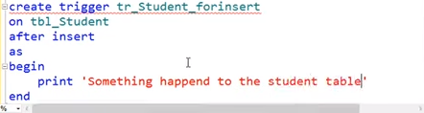

Inserted ek magic table ha jismy newly added row aurtomatically store ho jati ha

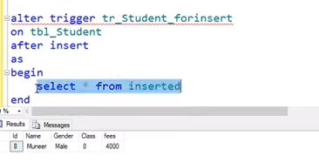

Deleted bhi ek magic table hota ha jismy currently deleted row store hooti h

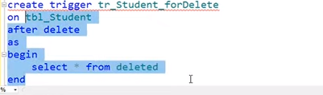

Yani jb bhi student table ma kuch nsert ho ga usky bad automatically trigger call ho ga.

1. What is data warehousing? Why might you use it? Data warehousing is the process of collecting, organizing, and analyzing large amounts of data from multiple sources to support business decision-making. Data warehouses are typically optimized for querying and analysis, and are often used to store historical data that can be used for trend analysis or forecasting.

Data warehousing can be useful in situations where an organization needs to analyze large amounts of data from multiple sources, such as customer transactions or web traffic logs. By collecting and storing this data in a data warehouse, organizations can gain insights into trends and patterns that can help inform business decisions.

1. What is a database schema? Why is it important? A database schema is a blueprint that defines the structure of a database, including the tables, columns, relationships, and constraints. The schema is used to ensure that the data in the database is consistent and accurate, and that it can be accessed and manipulated in a predictable way.

The schema is important for several reasons, including:

* Data integrity: The schema defines the rules and constraints that ensure that the data in the database is consistent and accurate.
* Application development: The schema provides a clear and consistent structure for application developers to work with, which can help improve productivity and reduce errors.
* Query performance: The

schema can help optimize query performance by ensuring that the data is organized in a way that allows for efficient querying.

1. What is a database transaction? Why is it important? A database transaction is a series of database operations that are executed as a single unit of work, either all together or not at all. Transactions are used to ensure that the database remains in a consistent state even in the event of errors or failures.

Transactions are important for several reasons, including:

* Data integrity: Transactions help ensure that the data in the database remains consistent and accurate, even in the event of errors or failures.
* Concurrency control: Transactions help manage concurrency by allowing multiple users to access and modify the same data without interfering with each other.
* Recovery: Transactions help ensure that the database can be recovered in the event of a failure or error.

1. What is database replication? Why might you use it? Database replication is the process of copying data from one database to another, typically in real-time or near-real-time. Replication can be used to improve performance, increase availability, or provide disaster recovery capabilities.

Replication can be useful in situations where an organization needs to distribute data across multiple locations or provide high availability for critical applications. By replicating data to multiple servers, organizations can ensure that the data is available even in the event of a server failure or other disaster.

1. What is NoSQL? How is it different from traditional relational databases? NoSQL (Not Only SQL) is a type of database that is designed to handle large volumes of unstructured or semi-structured data. Unlike traditional relational databases, NoSQL databases do not rely on a fixed schema, and can store data in a variety of formats, including key-value pairs, documents, and graphs.

NoSQL databases are typically more scalable and flexible than traditional relational databases, and can be better suited for handling large volumes of unstructured data, such as social media posts or sensor data. However, they can also be more complex to manage and may not be suitable for all types of data

Top of Form

**Indexing**

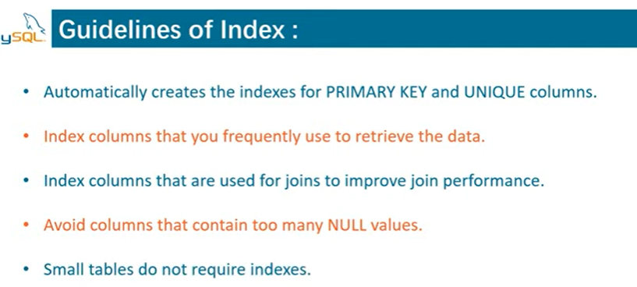

An index is a data structure that allows us to add indexes in the existing table. It enables you to improve the faster retrieval of records on a database table. It creates an **entry** for each value of the indexed columns. We use it to quickly find the record without searching each row in a database table whenever the table is accessed. We can create an index by using one or more **columns** of the table for efficient access to the records.

When a table is created with a primary key or unique key, it automatically creates a special index named **PRIMARY**. We called this index as a clustered index. All indexes other than PRIMARY indexes are known as a non-clustered index or secondary index.

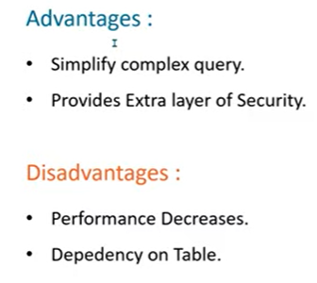

[**https://www.javatpoint.com/mysql-clustered-vs-non-clustered-index**](https://www.javatpoint.com/mysql-clustered-vs-non-clustered-index)

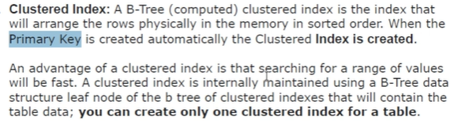

**We can create only one clustered index in one table because one table can have only one primary key for which automatically clustered index is created.** 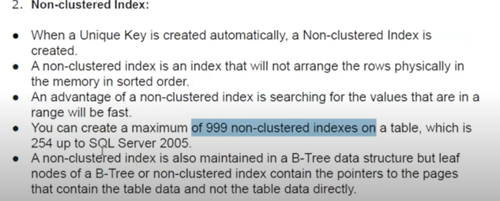

**what will happen if i will use where with group by instea of having clause.**

Using a WHERE clause instead of a HAVING clause with a GROUP BY clause will produce different results in SQL queries.

The WHERE clause is used to filter the rows returned by a query before any grouping or aggregation takes place. The WHERE clause applies the filter to each individual row in the table before the rows are grouped or aggregated.

On the other hand, the HAVING clause is used to filter the groups formed by the GROUP BY clause. The HAVING clause applies the filter to the result of the grouping and aggregation.In other words, the WHERE clause filters individual rows before they e grouped, while the HAVING clause filters groups after they have been formed.

Here's an example to illustrate the difference between WHERE and HAVING with GROUP BY:

Suppose we have a table called "sales" with columns "product", "category", and "amount". We want to find the total amount sold for each category where the total amount sold is greater than 1000.

Using WHERE clause:

SELECT category, SUM(amount)

FROM sales

WHERE amount > 1000

GROUP BY category;

This query will first filter the rows where amount is greater than 1000 and then group the remaining rows by category, and sum the amount for each group.

Using HAVING clause:

SELECT category, SUM(amount)

FROM sales

GROUP BY category

HAVING SUM(amount) > 1000;

This query will group the rows by category, sum the amount for each group, and then filter the groups where the sum of amount is greater than 1000.

Therefore, if you use a WHERE clause instead of a HAVING clause with GROUP BY, you may end up filtering out rows that belong to a group that meets the condition specified in the WHERE clause. This can result in incorrect or incomplete results.

**NULLIF**

1. **SELECT** NULLIF("Hello", "404");

The following MySQL statement compares both expressions. If expression1 = expression2, it returns NULL. Otherwise, it will return expression1.

**Output:**

Hello

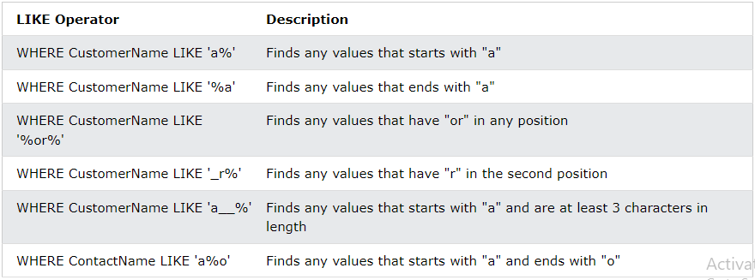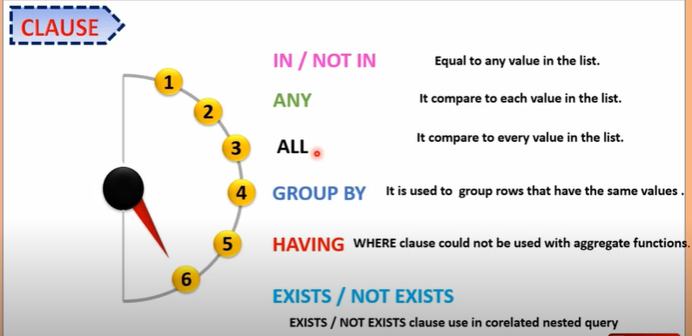

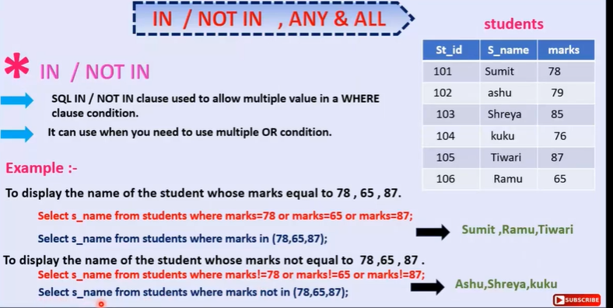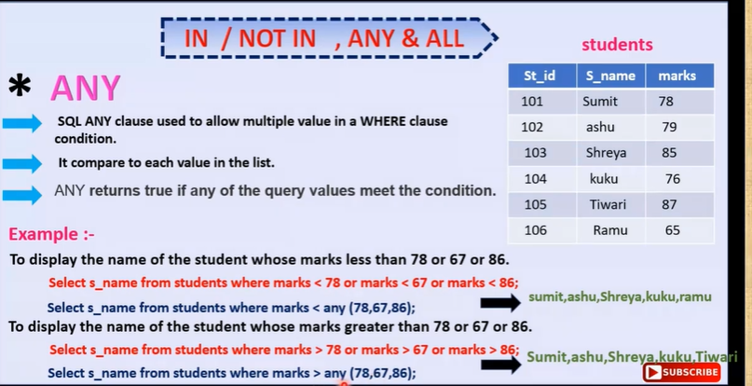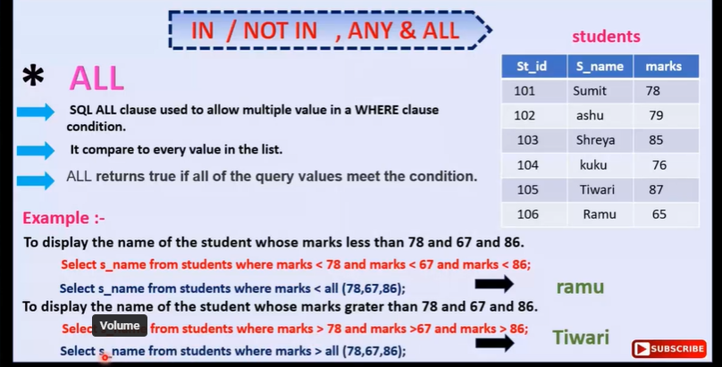

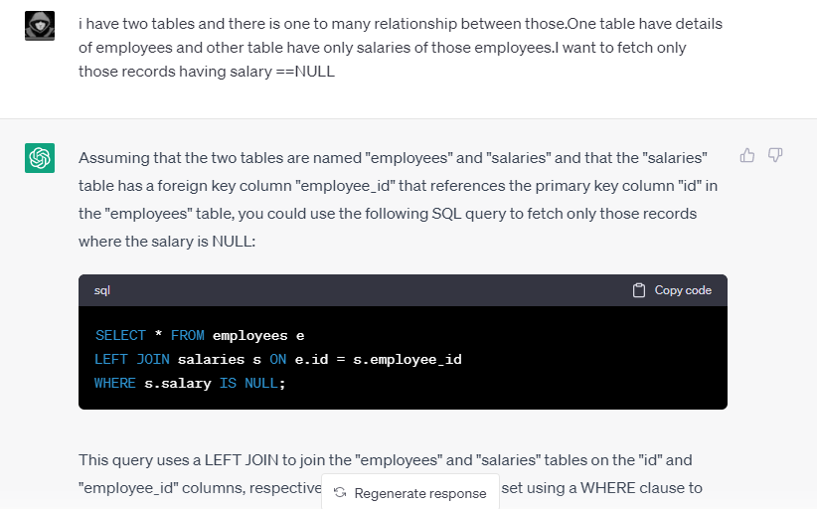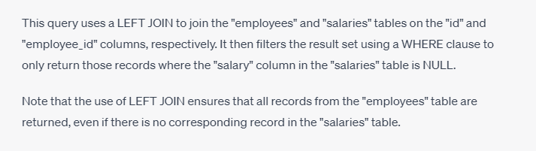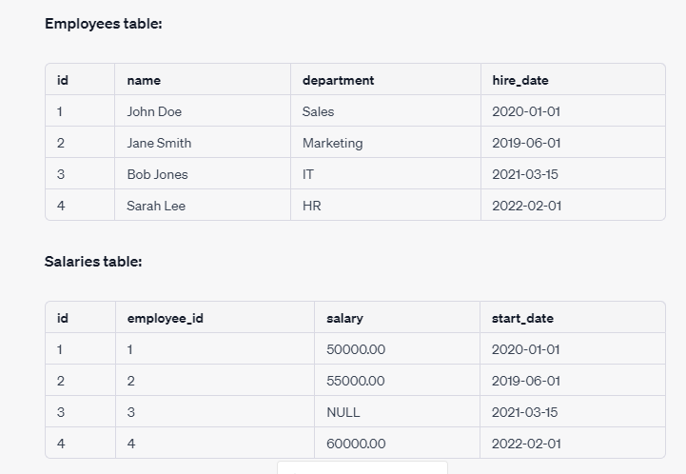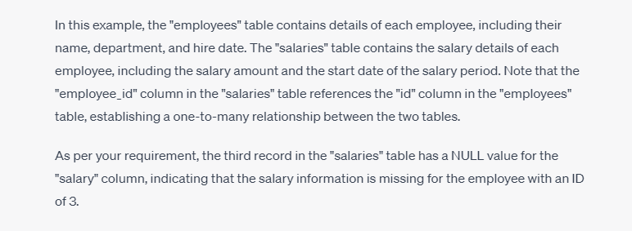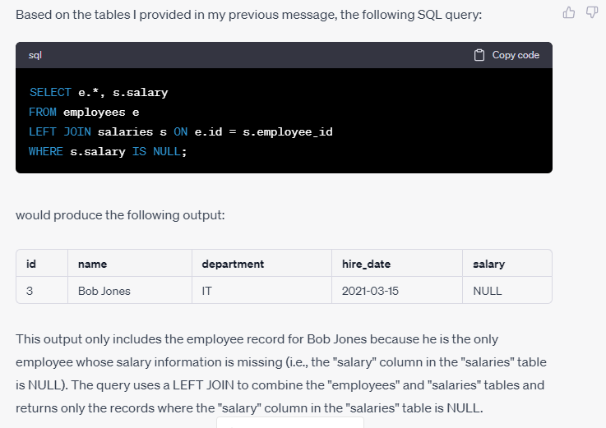

**One to many relationship**

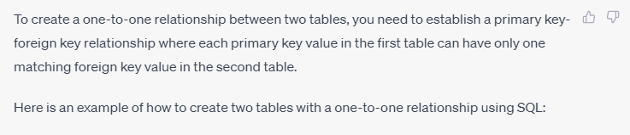

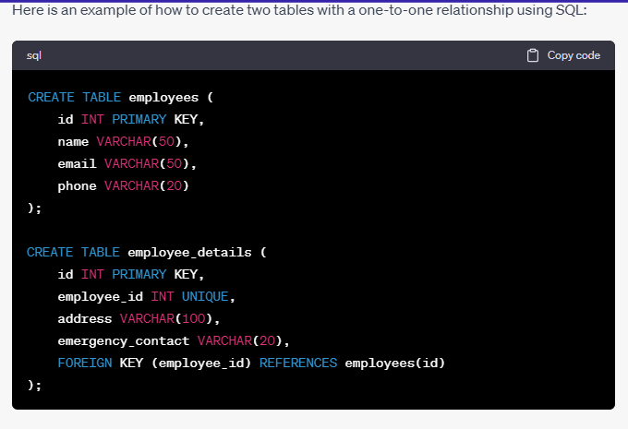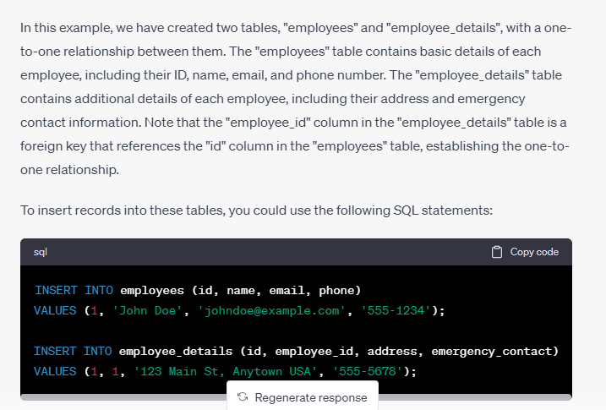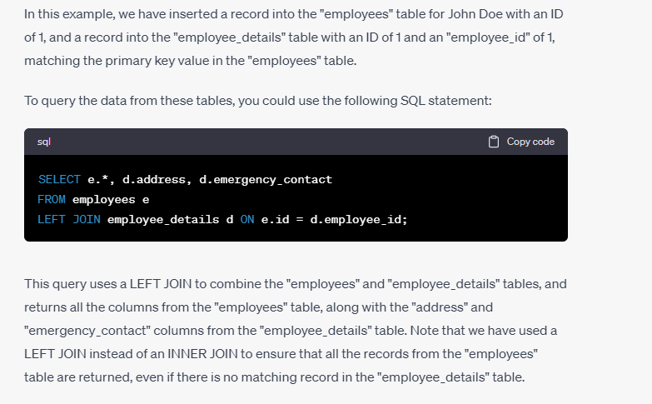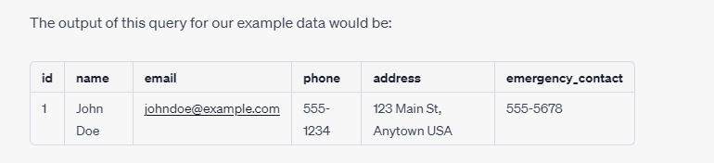

**One to One relationship**

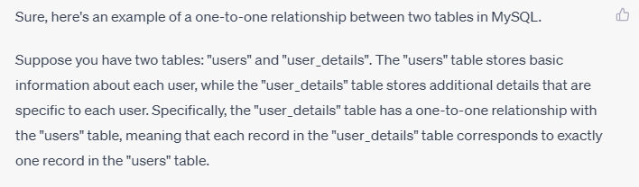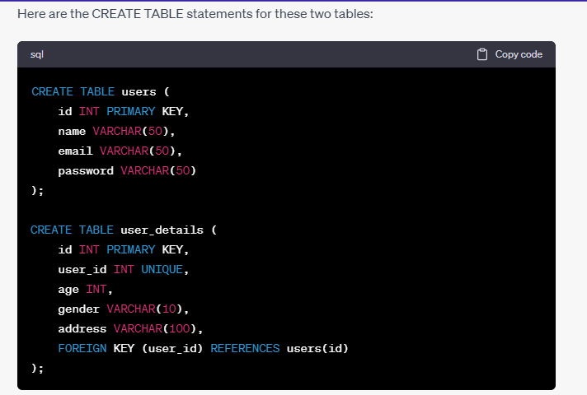

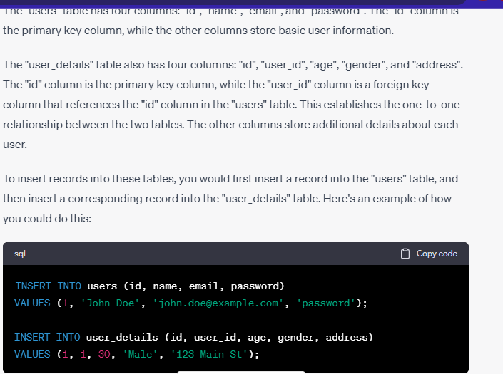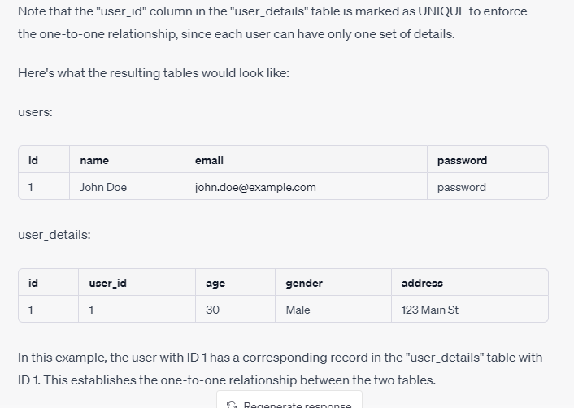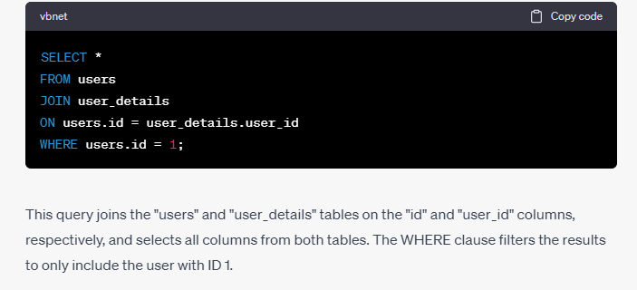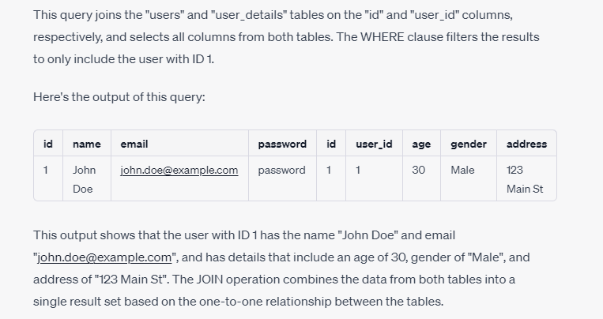

**Many to Many example**



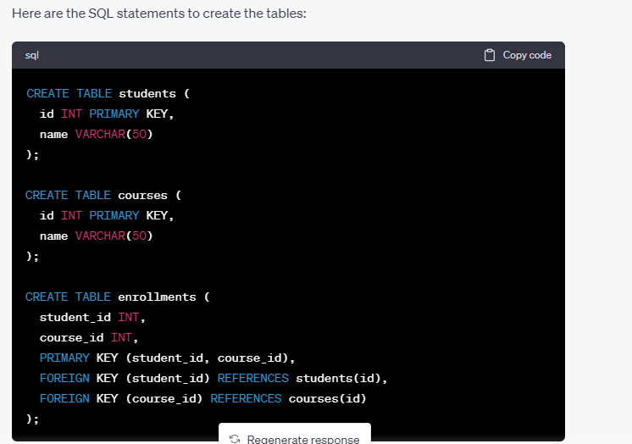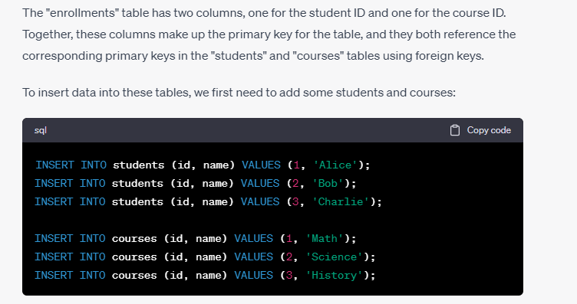

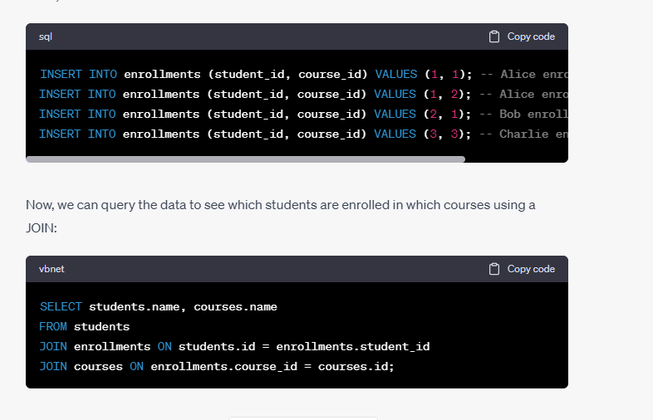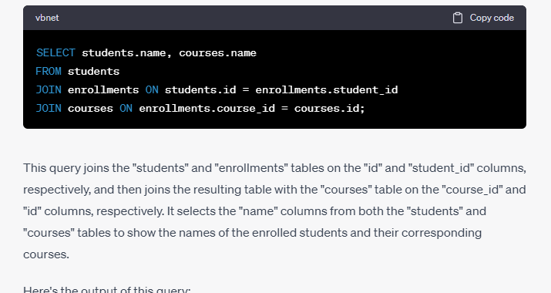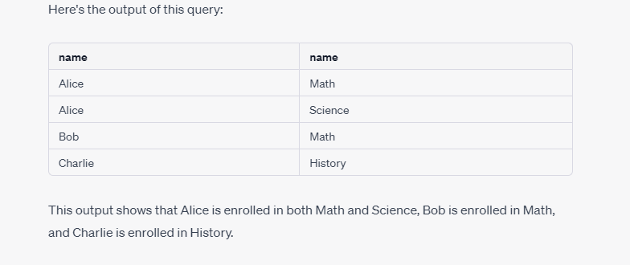



**Views**

Views are virtual tables that do not store any data physically. Instead, they are based on a SELECT statement that retrieves data from one or more tables in a database. When you create a view, you are defining a set of rules for selecting data from the underlying tables, and you can then query the view as if it were a physical table. In this way, views provide several advantages and disadvantages, as well as real-life applications.

Advantages of Views:

1. Simplify complex queries: Views can simplify complex queries by combining data from multiple tables into a single virtual table, making it easier to query and analyze data.
2. Data security: Views can be used to restrict access to sensitive data by limiting the columns and rows that are visible to specific users or roles.
3. Data consistency: Views can be used to ensure data consistency by presenting a consistent view of data across multiple tables, even if the underlying data is stored in different formats or with different structures.
4. Performance optimization: Views can improve query performance by precomputing expensive calculations or aggregations, and storing the results in the view.

Disadvantages of Views:

1. Performance overhead: Views can add performance overhead, especially when dealing with large amounts of data, as the database must compute the view's SELECT statement each time the view is queried.
2. Maintenance overhead: Views can require maintenance overhead, as any changes to the underlying tables must be reflected in the view's SELECT statement.
3. Limited functionality: Views have limited functionality compared to physical tables, as they cannot be used for some database operations such as inserting, updating, or deleting data.

Real-life applications of Views:

1. Reporting: Views are commonly used in business intelligence and reporting applications to simplify complex queries and present data in a more user-friendly format.
2. Security: Views can be used to restrict access to sensitive data, such as financial or medical records, by limiting the columns and rows that are visible to specific users or roles.
3. Data integration: Views can be used to integrate data from different sources or systems into a single view, making it easier to query and analyze data.
4. Performance optimization: Views can be used to optimize query performance by precomputing expensive calculations or aggregations, and storing the results in the view. For example, a view could be created that calculates monthly sales totals from a large sales table, so that the view can be queried instead of the entire sales table.
5. Why we use View?
6. MySQL view provides the following advantages to the user:
7. **Simplify complex query**
8. It allows the user to simplify complex queries. If we are using the complex query, we can create a view based on it to use a simple SELECT statement instead of typing the complex query again.
9. **Increases the Re-usability**
10. We know that View simplifies the complex queries and converts them into a single line of code to use VIEWS. Such type of code makes it easier to integrate with our application. This will eliminate the chances of repeatedly writing the same formula in every query, making the code reusable and more readable.
11. **Help in Data Security**
12. It also allows us to show only authorized information to the users and hide essential data like personal and banking information. We can limit which information users can access by authoring only the necessary data to them.
13. **Enable Backward Compatibility**
14. A view can also enable the backward compatibility in legacy systems. Suppose we want to split a large table into many smaller ones without affecting the current applications that reference the table. In this case, we will create a view with the same name as the real table so that the current applications can reference the view as if it were a table.

**Scenario Based Question**

There are different users that can do different posts on facebook and different users can do different comments on different posts.Make schemas and tables and write queries as well and also make relationship between all of these.

**Answer:** 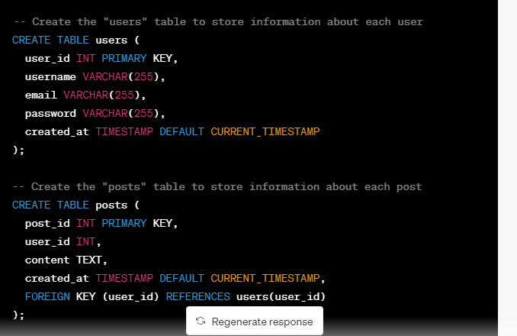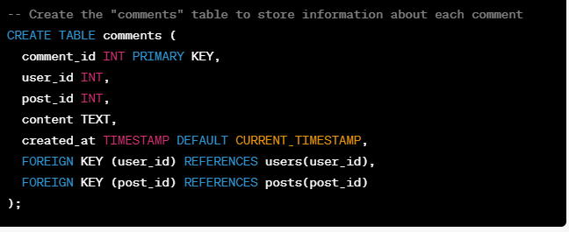

In this schema, we have three tables: "users", "posts", and "comments". The "users" table stores information about each user, such as their username, email, and password. The "posts" table stores information about each post, including the content of the post and the ID of the user who created it. The "comments" table stores information about each comment, including the content of the comment, the ID of the user who created it, and the ID of the post it belongs to.

To establish relationships between these tables, we use foreign keys. The "posts" table has a foreign key referencing the "users" table, indicating that each post belongs to a single user. Similarly, the "comments" table has foreign keys referencing both the "users" and "posts" tables, indicating that each comment belongs to a single user and a single post.

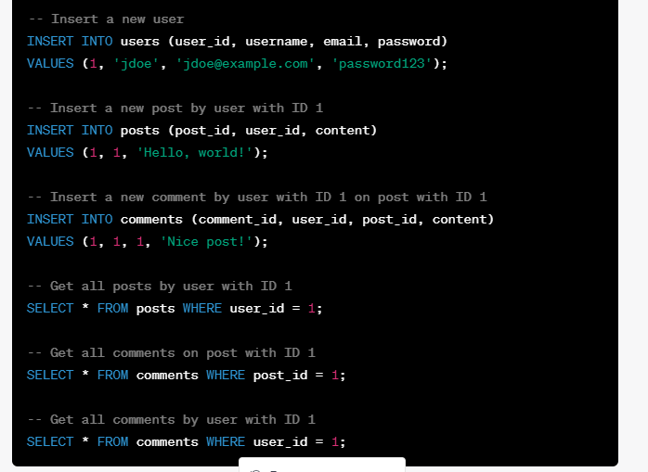These are just a few simple examples of queries you could run on this schema. Depending on the specific requirements of your application, you may need to write more complex queries or modify the schema.

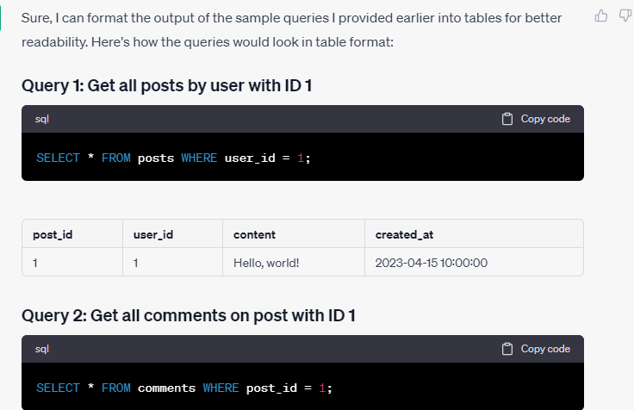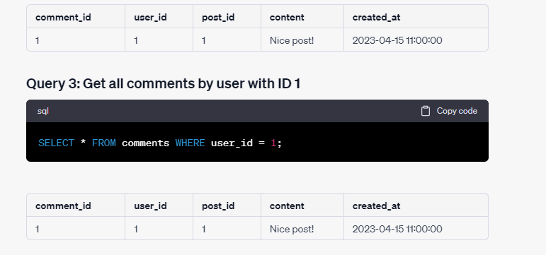

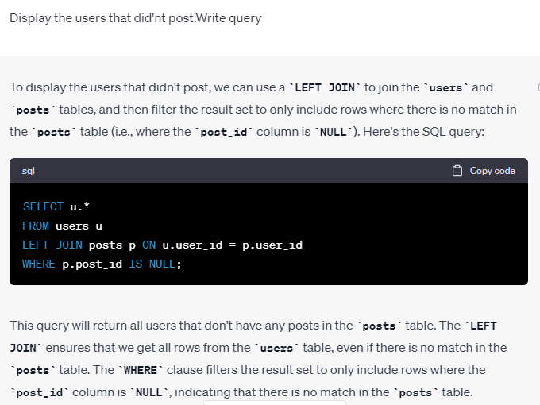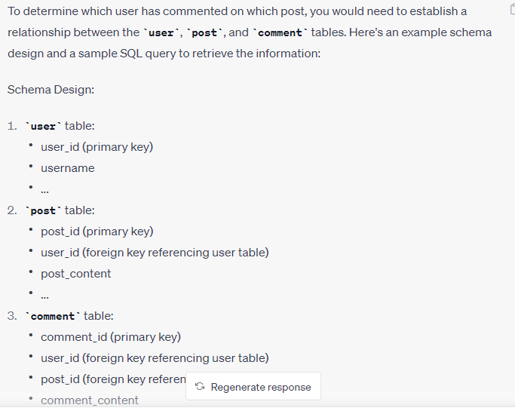

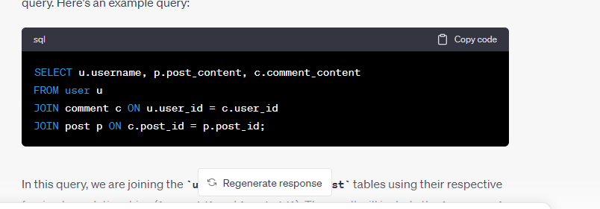You can customize the **SELECT** clause to include only the columns you're interested in, such as the **user_id**, **username**, or **email** columns.

**What is Row Number**

# 

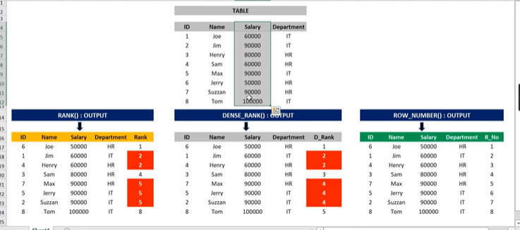

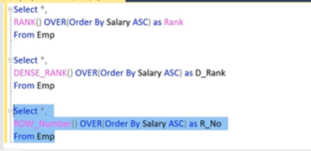

Over ma kisi column ka nam dena zarori ha

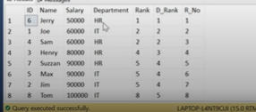

https://www.youtube.com/watch?v=a3WkE-VtR9k

# **Find Nth Highest Salary in SQL**

Method1:

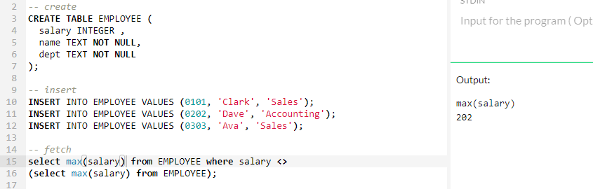

**Method2:**

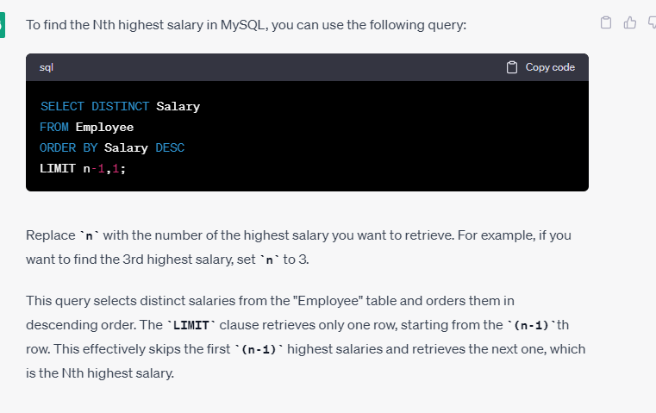

**Method 3:**

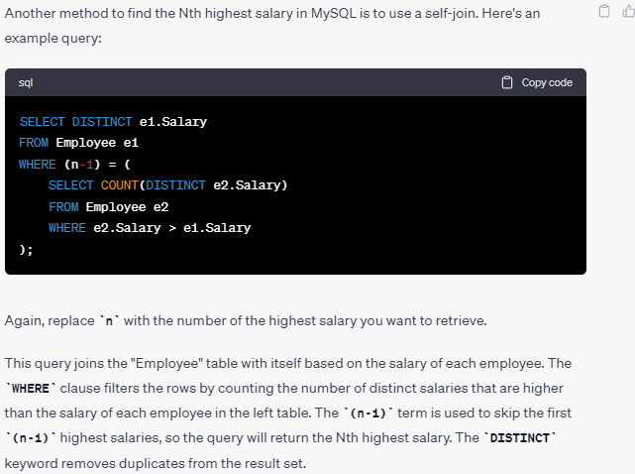

<https://www.youtube.com/watch?v=dR2fOw_DRiE&list=PL5mjp3QjkuoLk46ELjdzLePMb1hUkDJHg>

**Method4:**

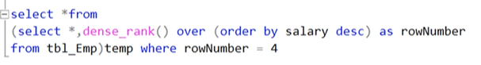

**Find the cumulative sum**

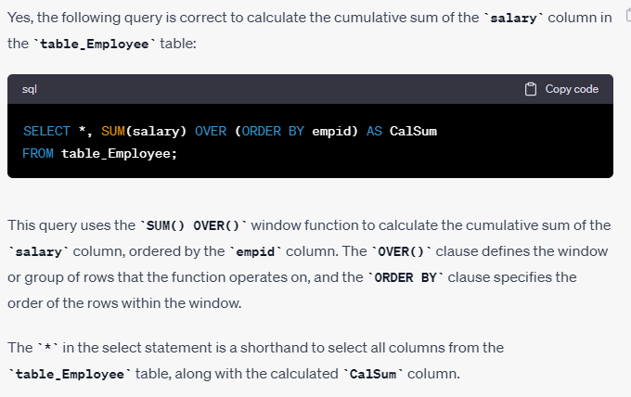

<https://www.youtube.com/watch?v=cec5s-uN3Sc&list=PL5mjp3QjkuoLk46ELjdzLePMb1hUkDJHg&index=4>

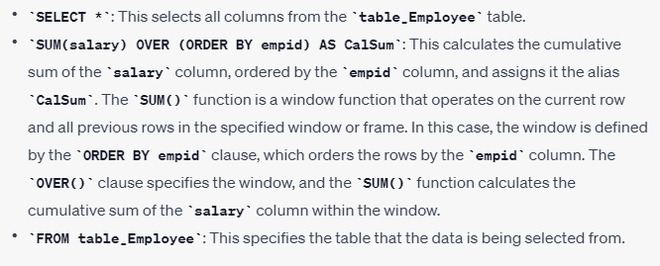

**Denial of service**

1. Denial of service: An attacker could launch a denial-of-service (DoS) attack by submitting a large number of malicious queries, which could overwhelm the server and cause it to crash or become unavailable.

**Remove duplicate rows**

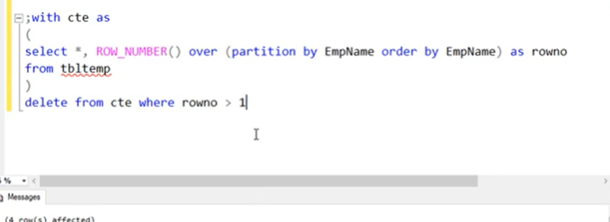

**Normalization**

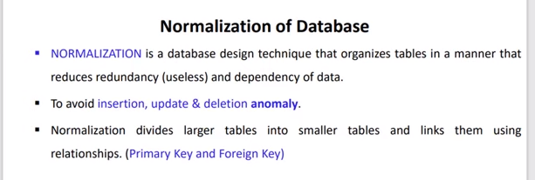 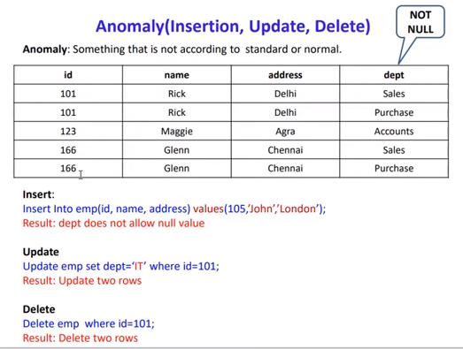 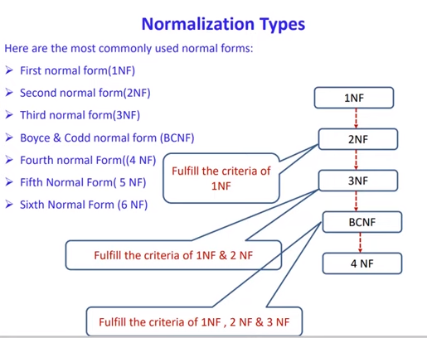 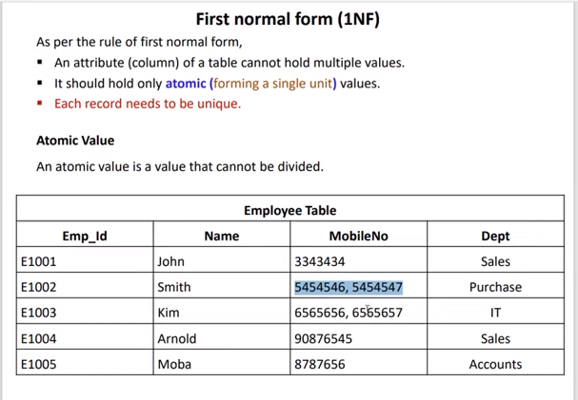 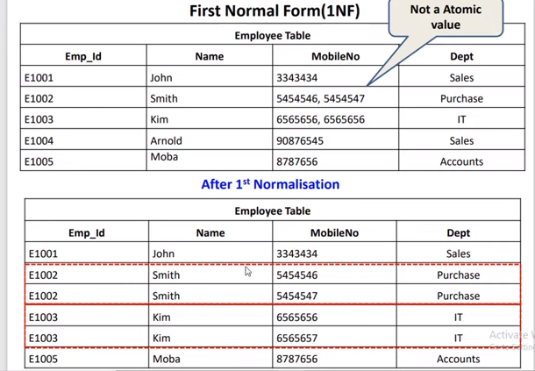 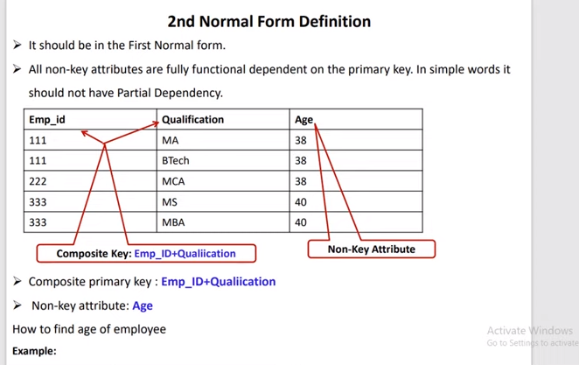 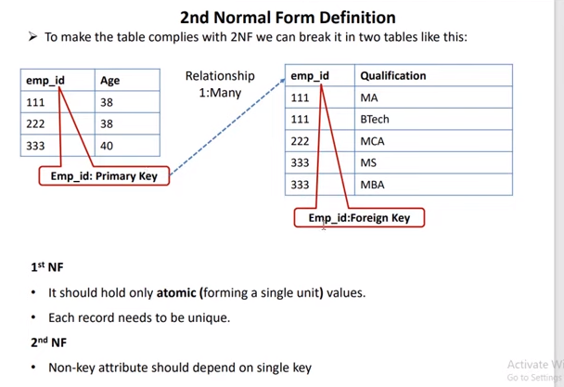 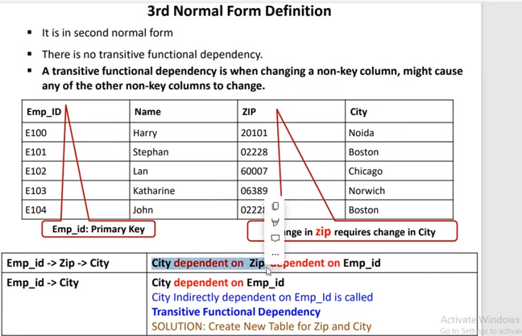 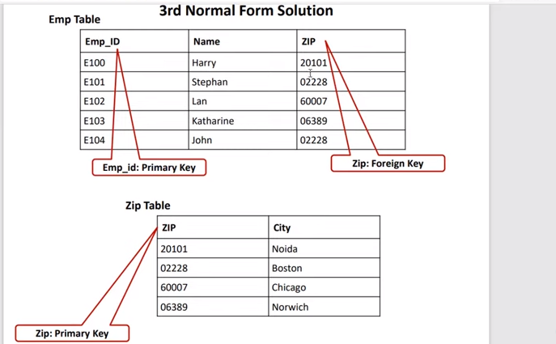 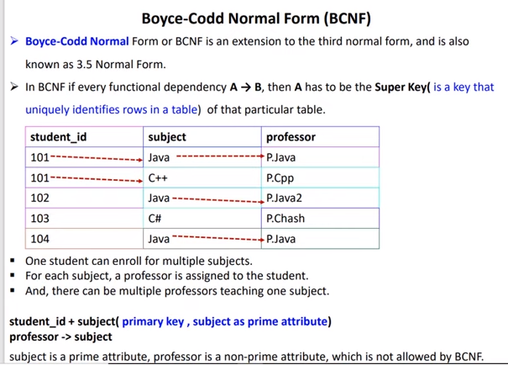 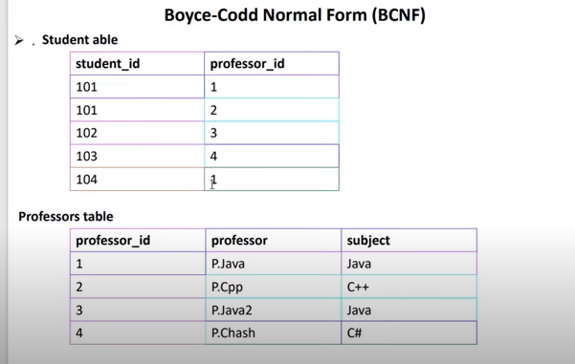 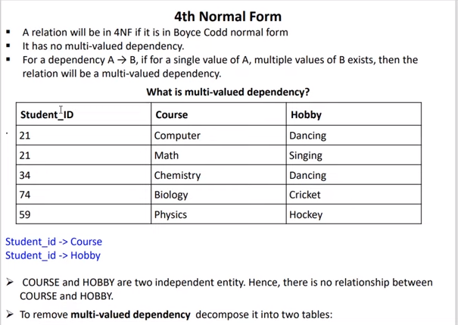 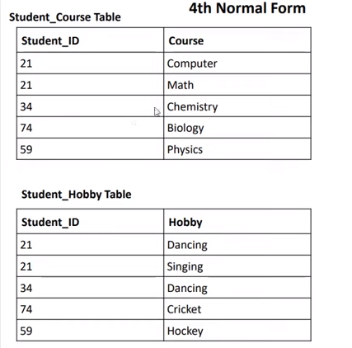

**Union vs Union All**

When comparing UNION vs. UNION ALL , there is one major difference: UNION only returns unique. UNION ALL returns all records, including duplicates. 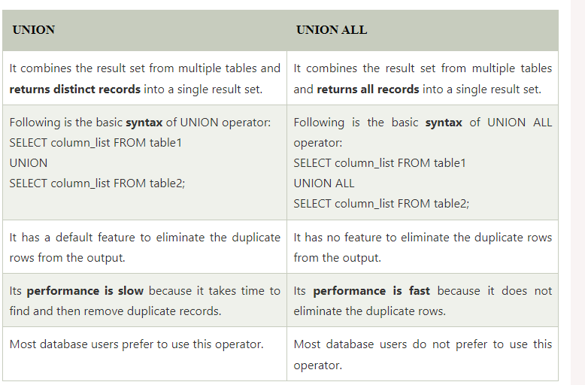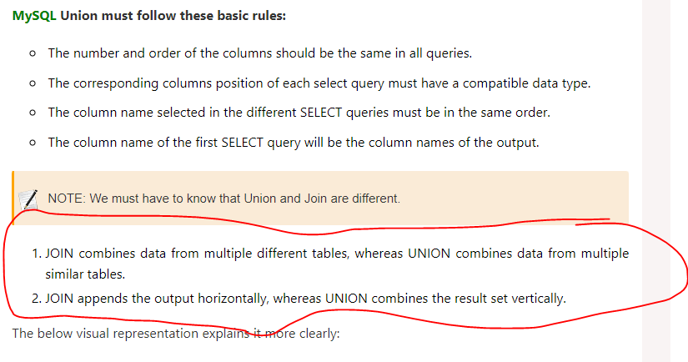

1. How do you optimize a database query?
   * Query optimization involves techniques like using indexes, optimizing joins, reducing unnecessary columns, and rewriting queries to improve performance.
2. How do you handle database backups and recovery?
   * Database backups involve making copies of the database to protect against data loss.
   * Recovery mechanisms restore the database to a previous state in case of data corruption or failure.
3. What is the difference between a clustered and non-clustered index?
   * A clustered index determines the physical order of data in a table.
   * A non-clustered index is a separate structure that stores a copy of the indexed columns along with a pointer to the corresponding data.

**Get Duplicate Rows**

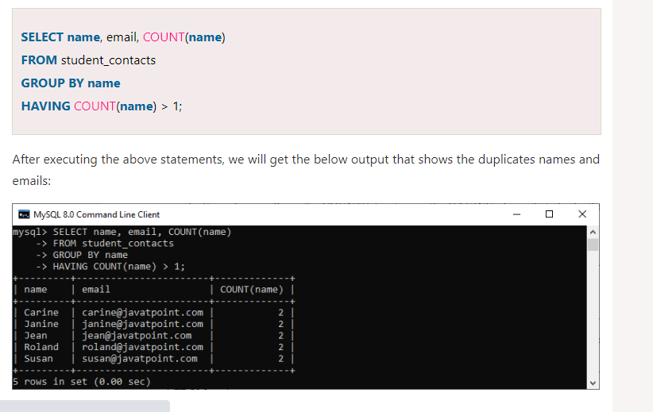

What is Indexing? Why we use indexing? Types of indexing? 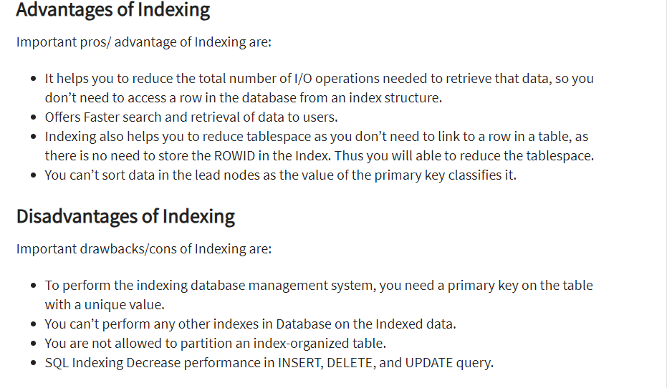

**Quesstion**

**You have a social media application. In which user can add posts. Now, you need to add a feature of comment on the post. Multiple users can write comment on multiple posts. How you add this functionality. Now, also add the feature of reply, where multiple user can write multiple reply in post of multiple users. Also draw tables and erd diagram and tell relationship etc as well**

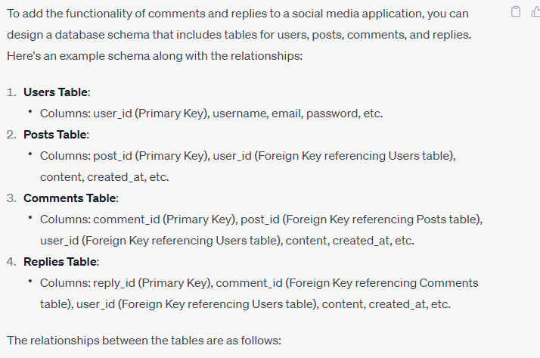

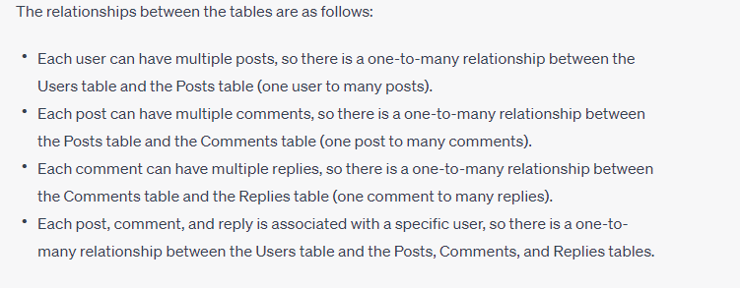

ERD

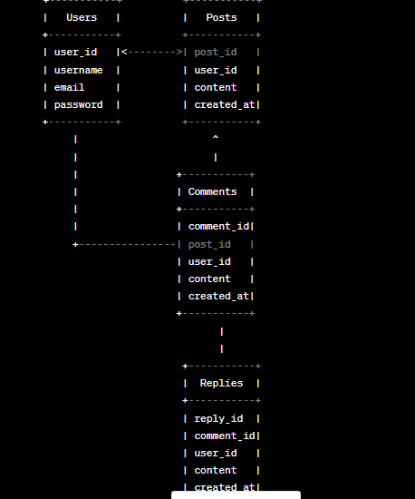

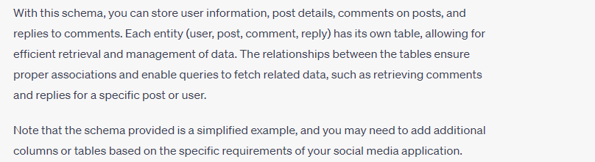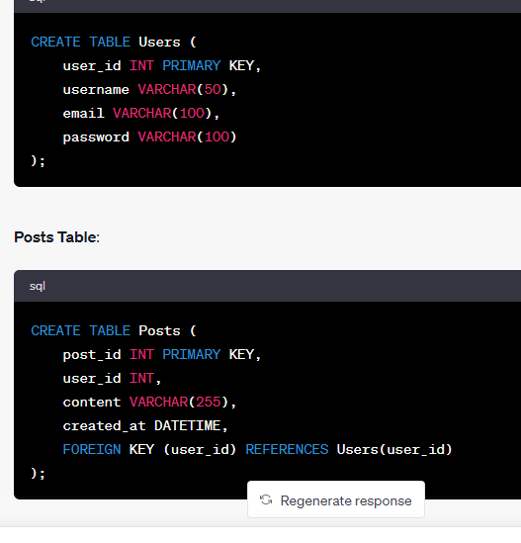

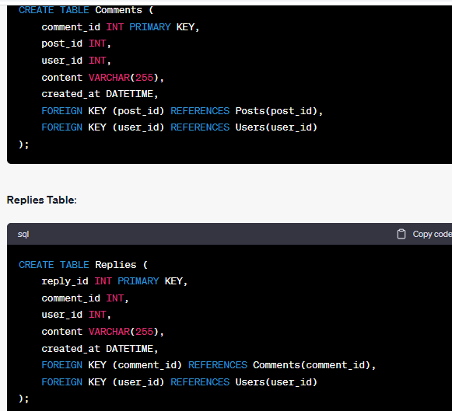

**Question**

**Draw an ERD for quiz management, Each quiz contain quiz name, quiz start time, quiz totat time, and list of questions and student answer.**

**Question is a MCQs based, Question has statement and 4 options and 1 answer.**

**Each quiz can contain multiple questions, and each question can be used in multiple quizzez.**

**Student can attempt the quiz and write answer for each question of quiz.**

**Write a query which display the quiz name, all the question statement of the quiz and student answer.**

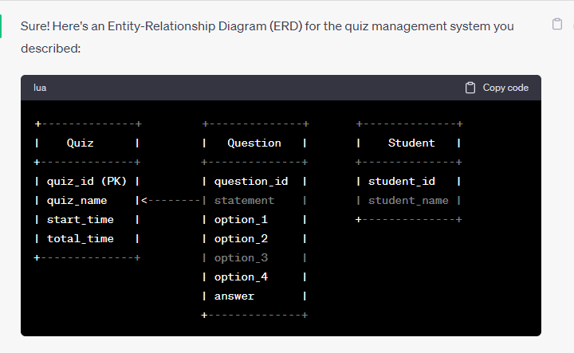

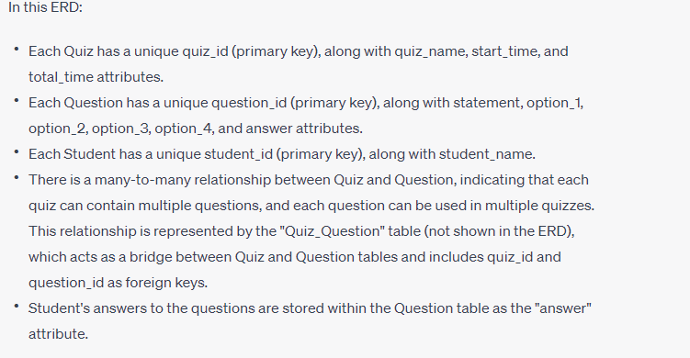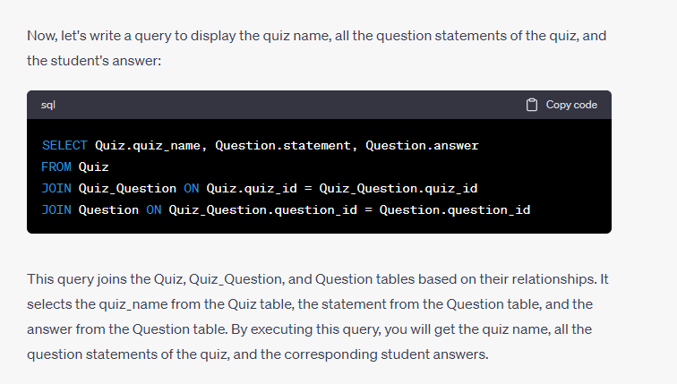

**Write a query to calculate total days of Employement in company for an employee ( difference between the current date and dateOfJoining)**

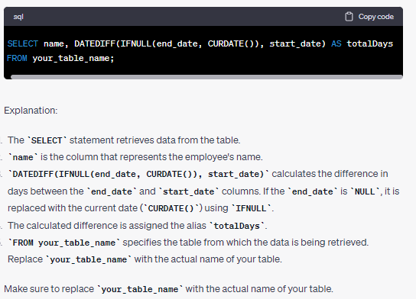

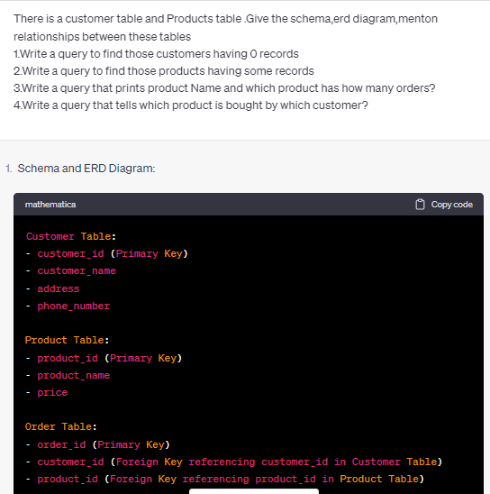

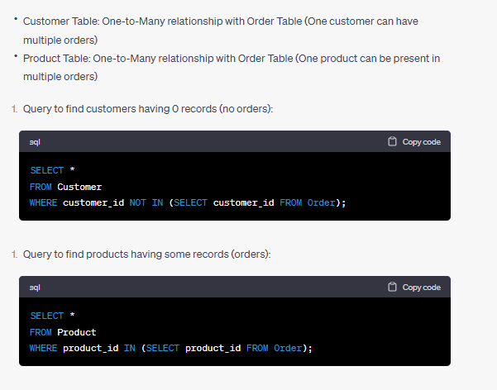

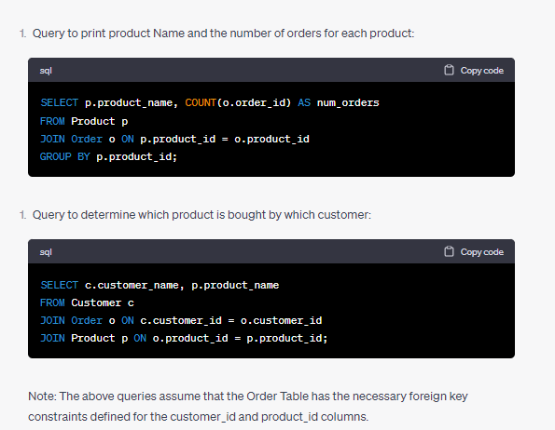

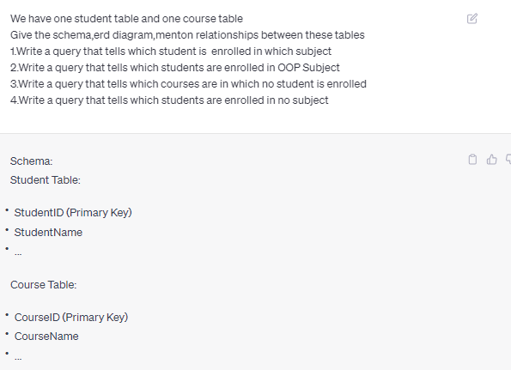

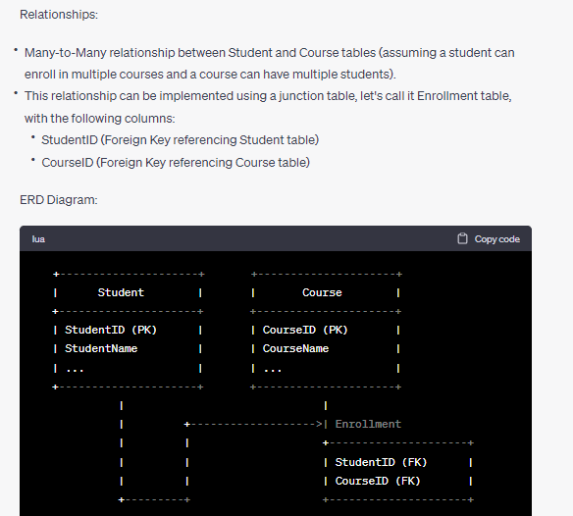 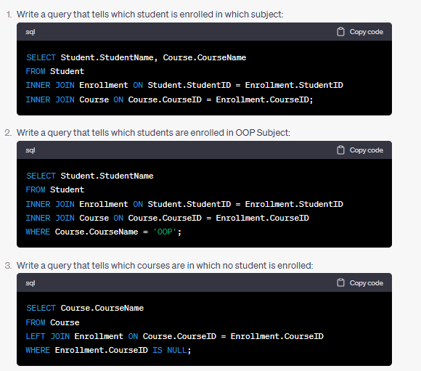 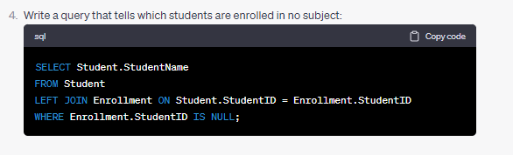  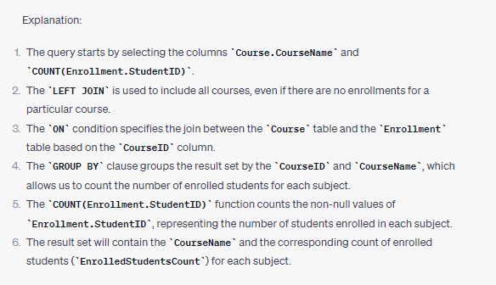

**Find Employee record that has Maximum Salary**

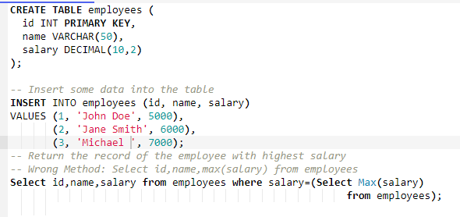

**Select id,name,max(salary) from employees**

**why this gives error**

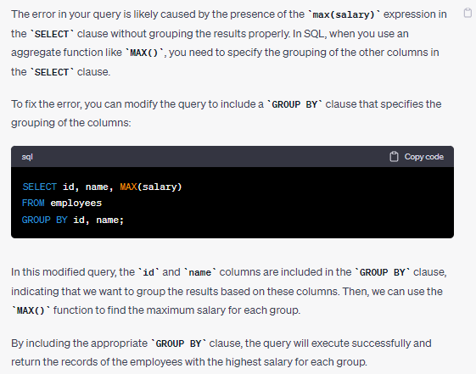

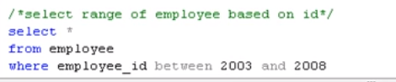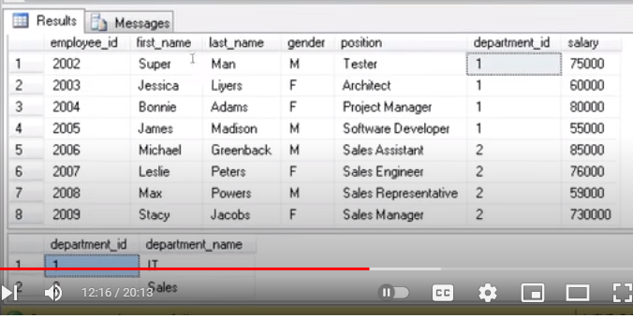

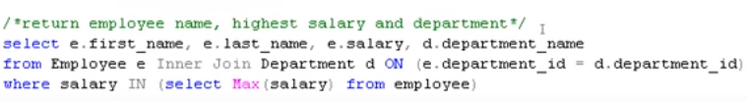

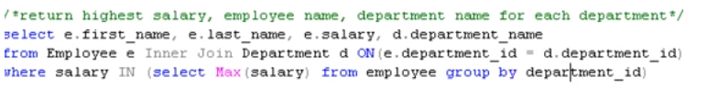

**Foreign Key** <https://www.youtube.com/watch?v=wofRkTxxME4>

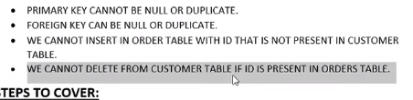

Note:Agr hamary pas koi keyword ha jaisy primary tu hum isi nam ka table nahi bana skty pr agr banana chhty hain tu usko [] ka andr likhna ho ga msln

Create table [TableName]

Create table [order]

**Scenario based question of Facebook**

There are different users that can do different posts on facebook and different users can do different comments on different posts.Make schemas and tables and write queries as well and also make relationship between all of these.Is it ok that the comment table will have the user id and post id so that we can know which user commented on which post Draw the Erd diagram. Explain the relationship between all the entities and also mention 1 M etc Give the code of creating the tables as well. Draw any class diagram or erd diagram Write a query that tells which post is posted by which user? Write a query that tells which comment is commented by which user? Write a query that tells which comment is commented on which post by which user? Write a query that tells which post dont have any comment Write a query that tells which user posts nothing Write a query that tells which Post dont have any replies Write a query that tells which comment has no replies Write a query that tells which user is the friend of which user?

OR

